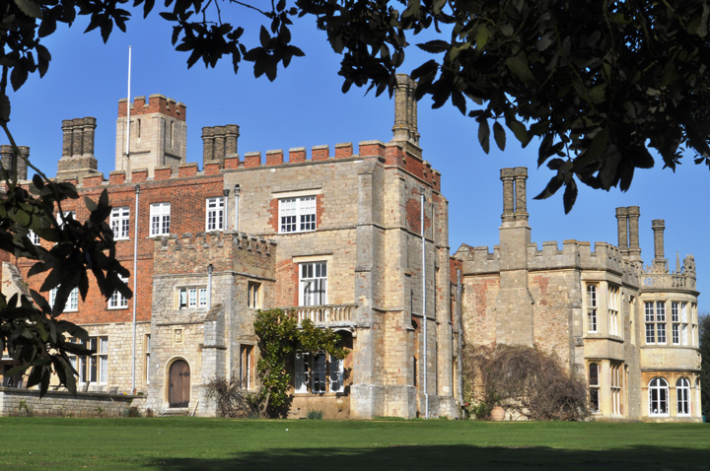

Starter

Visit gardens - possibly Cambridge Botanical Gardens, Wimpole Hall, Audley End. Get a sense of a typically British pastoral scene.

Visit the ‘Talk to Frank’ website and read the real life accounts of drug addicts.

Main

Read

‘As You Like It’ by William Shakespeare

Arcadia by Tom Stoppard

Trainspotting by Irvine Welsh

Dessert

Read another book by Irvine Welsh

Watch the film ‘Sunshine on Leith’

Read a book written in dialect – for example ‘The Colour Purple’ or ‘The Help’

Go to see ‘As you Like It’ 7th -26th July St John’s College Gardens in Cambridge.

This is your summer menu to support your transition from AS to A2:

Main courses are compulsory.

Choose activities from the starter and dessert menus to enrich and develop your understanding ready for A2.

ENGLISH LANGUAGE AND LITERATURE A2