THE AMERICAN WEST, 1835-1895

REVIEW BOOKLET

[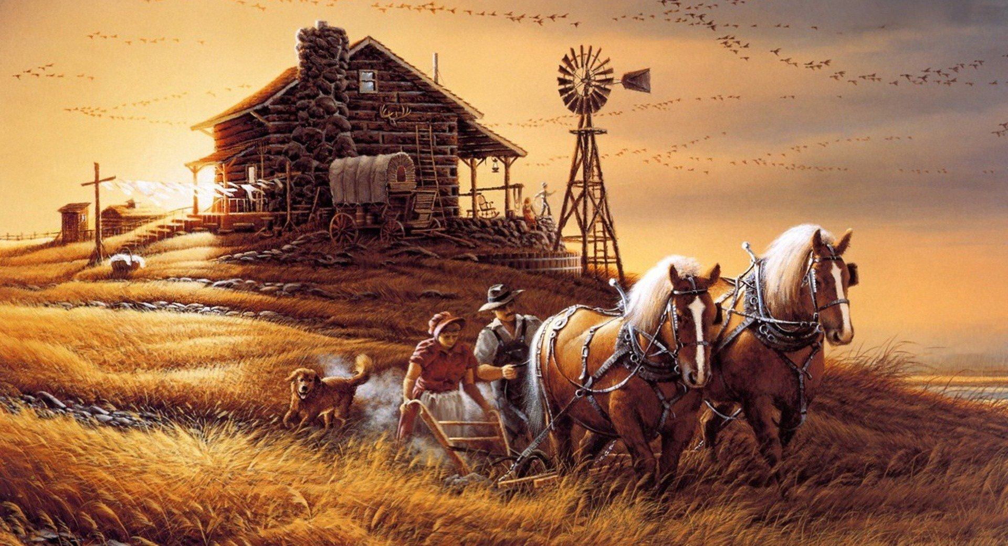](https://www.google.co.uk/url?sa=i&rct=j&q=&esrc=s&source=images&cd=&cad=rja&uact=8&ved=0ahUKEwi-8oyc46bVAhWDbxQKHdcdDTUQjRwIBw&url=https://wall.alphacoders.com/by_sub_category.php?id=168465&psig=AFQjCNFZD1dP8NecUytYbPKA0u1KA8W52A&ust=1501152557256902)

**CONTENTS**

**TOPIC 1: EARLY SETTLEMENT OF THE WEST, 1835-1862**

1. Who were the Plains Indians (their beliefs and way of life)
2. Who migrated (moved) West and why?
3. What conflict and tension took place as a result of new settlers?

**TOPIC 2: DEVELOPMENT OF THE PLAINS, 1862-1876**

1. How and why did more people move West?
2. Why did the Cattle Industry develop?
3. How did new inventions and settlement affect the Indians?

**TOPIC 3: CONFLICTS AND DESTRUCTION, 1876-1895**

1. How did farming, the cattle industry and settlement change in the 1880s and 90s?
2. A) What conflict took place between the Plains Indians and the White Settlers?

B) What issues of law and order were there in the 1880s?

1. How were the Plains Indians and their way of life finally defeated?

**EXTENSION:**

1. Making links
2. Extra Reading/Research

|  |  |  |  |  |  |  |  |  |  |  |  |
| --- | --- | --- | --- | --- | --- | --- | --- | --- | --- | --- | --- |
|  | **TOPIC 1: EARLY** | | | **TOPIC 2: DEVELOPMENT** | | | **TOPIC 3: DESTRUCTION** | | | **EXTENSION** | |
|  | **1** | **2** | **3** | **4** | **5** | **6** | **7** | **8** | **9** | **10** | **11** |
| Completed  [Image result for tick](https://www.google.co.uk/url?sa=i&rct=j&q=&esrc=s&source=images&cd=&cad=rja&uact=8&ved=0ahUKEwj4oq3A5abVAhWEVRQKHTUSB-4QjRwIBw&url=http://www.clipartpanda.com/categories/tick-20clipart&psig=AFQjCNE7q1NTnNjV8DdGUgIa17zIGWWXkA&ust=1501153173422649)page? |  |  |  |  |  |  |  |  |  |  |  |
| [Image result for tick](https://www.google.co.uk/url?sa=i&rct=j&q=&esrc=s&source=images&cd=&cad=rja&uact=8&ved=0ahUKEwj4oq3A5abVAhWEVRQKHTUSB-4QjRwIBw&url=http://www.clipartpanda.com/categories/tick-20clipart&psig=AFQjCNE7q1NTnNjV8DdGUgIa17zIGWWXkA&ust=1501153173422649)Activities [Image result for tick](https://www.google.co.uk/url?sa=i&rct=j&q=&esrc=s&source=images&cd=&cad=rja&uact=8&ved=0ahUKEwj4oq3A5abVAhWEVRQKHTUSB-4QjRwIBw&url=http://www.clipartpanda.com/categories/tick-20clipart&psig=AFQjCNE7q1NTnNjV8DdGUgIa17zIGWWXkA&ust=1501153173422649)  [Image result for tickImage result for tick](https://www.google.co.uk/url?sa=i&rct=j&q=&esrc=s&source=images&cd=&cad=rja&uact=8&ved=0ahUKEwj4oq3A5abVAhWEVRQKHTUSB-4QjRwIBw&url=http://www.clipartpanda.com/categories/tick-20clipart&psig=AFQjCNE7q1NTnNjV8DdGUgIa17zIGWWXkA&ust=1501153173422649) |  | | |  | | |  | | |  | |
| [Image result for tick](https://www.google.co.uk/url?sa=i&rct=j&q=&esrc=s&source=images&cd=&cad=rja&uact=8&ved=0ahUKEwj4oq3A5abVAhWEVRQKHTUSB-4QjRwIBw&url=http://www.clipartpanda.com/categories/tick-20clipart&psig=AFQjCNE7q1NTnNjV8DdGUgIa17zIGWWXkA&ust=1501153173422649)Exam-style question |  | | |  | | |  | | |  | |

**The Spirit World**

The Great Spirit and nature

Animal Power

Dances and Ceremonies

Circles

**Family Roles**

* Children
* Men
* Women
* Old people

**War**

Different fighting techniques

Reasons for War

Scalping

Counting Coup

**1**

**The Importance of Horses**

**Buffalo**

* Dance
* Hunt
* Uses

**The Tipi**

* Design

**US Government Policy**

* The Bureau of Indian Affairs
* The Indian Removal Act
* Indian Appropriations Act

**WHO MIGRATED (MOVED) WEST AND WHY?**

**2**

*Reasons people moved West*

PULL FACTORS

PUSH FACTORS

*Difficulties of the journey.* CASE STUDIES *: The Donner and Knight family*

**THE MORMONS**

Missouri

Nauvoo, Illinois

Kirtland, Ohio

Adapting

Success at SALT LAKE!!

Travelling West

**WHAT CONFLICT AND TENSION TOOK PLACE AS A RESULT OF NEW SETTLERS?**

**3**

**Fort Laramie Treaty Fact File**

Date:

What did it promise?

How successful was it and why?

|  |  |  |
| --- | --- | --- |
| **Terms of the Treaty** |  | **Consequences** |
| Territories set out for Plains Indian tribes | More people settled in the West |
| White settlers allowed across Plains Indian territories | More people could move West to build homes and a new life |
| Railroad surveyors and military posts in Plains Indian territories | The Plains Indians lost their independence |
| Tribes to receive resources from the US government | Large areas of land were fenced off and the Indians were forced onto this land, known as a ‘Reservation’. |

Match the terms below to the consequences.

**The Mountain Meadow Massacre, 1858.**

|  |  |  |
| --- | --- | --- |
| CAUSES | EVENT DETAILS | CONSEQUENCES |
|  |  |  |

**The Problem of Lawlessness**

|  |  |  |
| --- | --- | --- |
| CAUSES | PROBLEMS | CONSEQUENCES- what did the government do to try and prevent problems? |
|  | * Robbery * Rowdyism * Killings * Vigilante action |  |

**HOW AND WHY DID MORE PEOPLE MOVE WEST, 1862-76?**

**4**

**TASK 1:** *Complete the table below.*

|  |  |  |  |  |
| --- | --- | --- | --- | --- |
|  | **YEAR** | Details of the event or Act | Why did this encourage people to move West? | Give each event a mark out of 10 for how important it was in encouraging people to move West |
| The End of the American Civil War |  |  |  |  |
| The Southern Homestead Act |  |  |  |  |
| The Timber Culture Act |  |  |  |  |
| The Desert Land Act |  |  |  |  |
| The Pacific Railroad Act |  |  |  |  |
| The Completion of the Transcontinental Railroad |  |  |  |  |

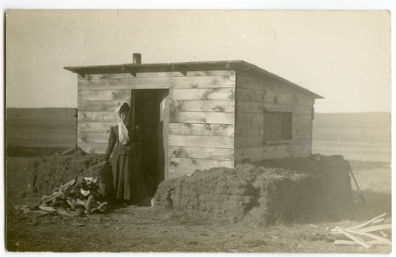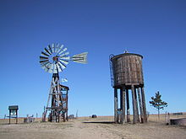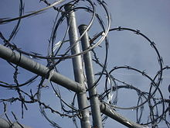**TASK 2:** *What do all of these images have in common? Can you label them?*

**4**

|  |  |
| --- | --- |
| **Word or Phrase** | **Either write a definition of the word or facts about the word or phrase on the left.** |
| Stage coach robbery |  |
| Bank robbery |  |
| Train robbery |  |
| Shootings |  |
| A Dime Novel |  |
| Buffalo Bill’s Wild West |  |
| US Marshals |  |
| The Texas Rangers |  |
| The Pinkerton Detective Agency |  |
| Vigilantism |  |

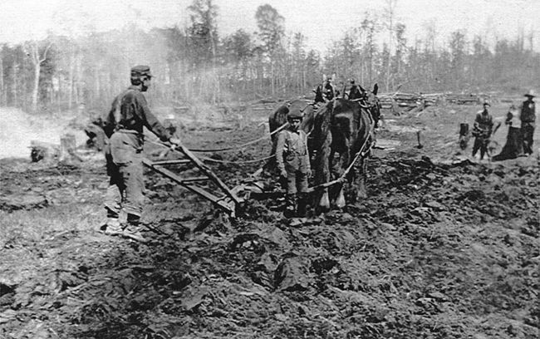

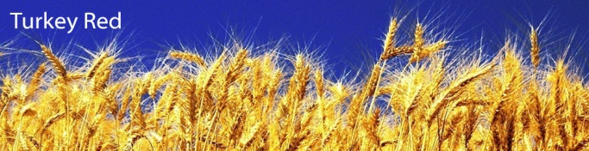

**TASK 3:** *Fill in the right-hand column.*

**WHY DID THE CATTLE INDUSTRY DEVELOP, 1860-1880**

**5**

**Why were each of these people or factors important to the development of the cattle industry?**

**HOW DID NEW INVENTIONS AND SETTLEMENT AFFECT THE PLAINS INDIANS?**

**6**

|  |  |  |  |
| --- | --- | --- | --- |
|  | **CAUSES** | **NARRATIVE OF CONFLICT** | **RESULTS** |
| **Little Crow’s War 1861-2** |  |  | * 2000 Santee Sioux transferred to a new r____________ called C____ C______. |
| **The Cheyenne Wars 1864-7** |  |  | * Chiefs signed the M________ Lodge T_____ agreeing to move to reservations. * Some disagreed and continued fighting. Black K______’s tribe were attacked and beaten and 50 Cheyenne women and children were taken h_______ * Some Arapaho, Cheyenne and Kiowa attacked white buffalo hunters but eventually gave in in _ _ _ _. |
| **Red Cloud’s War 1866-8** |  |  | * The Fort Laramie Treaty was… * In 1868, President G_______ introduced a Peace Policy that stated…  1. Indians must move to R___________ and learn to be American c_______. 2. Indian a_______ were replaced with C________ churchmen. 3. Army officers p_________ Indians and s_________ them leaving the reservations. |

Total War helped the US Army defeat the Plains Indians because…

Winter Campaigns helped the US Army defeat the Plains Indians because…

**Changes in FARMING, THE CATTLE INDUSTRY and SETTLEMENT**

**7**

***Changes in Farming***

Railroads Cheap, new machinery

* New windmills
* James _______ improved John _______’s sodbuster.
* Barbed wire was used _____.

BUT

Bad weather thousands become bankrupt

1889-93 11,000 homesteads were repossessed.

***Changes in Cattle Ranching***

The open range ended in 1885 because…

As a result of this…

***Changes in Settlement***

***More people move West***

* The Exoduster Movement, 1879
* The Oklahoma Land Rush of 1893

**A) WHAT CONFLICT TOOK PLACE BETWEEN THE PLAINS INDIANS AND THE WHITE SETTLERS? 1875-1890**

**8**

|  |  |  |  |
| --- | --- | --- | --- |
|  | CAUSES | NARRATIVE OF EVENT | RESULTS |
| The Great Sioux War,  1876-7 |  |  |  |
| The Battle of Little Bighorn,  1876 |  |  |  |

**B) WHAT ISSUES OF LAW AND ORDER WERE THERE IN THE 1880S?**

**8**

|  |  |  |  |
| --- | --- | --- | --- |
|  | CAUSES | NARRATIVE OF EVENT | RESULTS |
| The Lincoln County War  _ _ _ _ |  |  |  |
| Wyatt Earp and the gunfight at the OK Corral,  _ _ _ _ |  |  |  |
| The Johnson County War,  _ _ _ _ |  |  |  |

**HOW WERE THE PLAINS INDIANS AND THEIR WAY OF LIFE FINALLY DEFEATED?**

**9**

1. ***Reservations and the Dawes Act, _ _ _ _***
2. ***Extermination of the Buffalo***
3. ***Government Policies that…***

* *Weakened the authority of the chief by…*
* *Changed their economy as…*
* *Changed their education by…*
* *Limited their religion as…*

**DESCRIBE EVENTS IN THEIR FINAL DEFEAT IN LESS THAN 30 words each.**

The Ghost Dance Movement-

The Wounded Knee Massacre-

**TOPIC 1: ACTIVITIES**

***Plains Indians***

1. **Are the following statements about the life of the Plains Indians true or false? Why?**

* *The Plains Indians believed that all living things had spirits of their own.*
* *The Plains Indians believed that owning land was important.*
* *The Plains Indians believed that it was not cowardly to run away when you were outnumbered in a fight.*
* *The Plains Indians depended on the buffalo for their way of life.*

1. **Explain in one sentence what you know about the following.**

* *Counting coup*
* *Warrior societies*
* *George Catlin*

1. **Which was more important to the Plains Indians: counting coup or the number of scalps you collected? Why?**
2. **List four reasons why the tipi was an ideal home for living on the Great Plains.**
3. **List five uses of the buffalo with the most important at the top and least important at the bottom.**

***Mormons and Settlement***

1. **Place the following events in chronological order:** *(try to add dates to each event)*

* *California Gold Rush*
* *The opening of the Oregon Trail*
* *The Mormon migration*
* *The Fort Laramie Trail*

1. **The following account of the concept of Manifest Destiny is by a student who has not revised thoroughly. Rewrite the account, correcting any errors.**

*“In 1845 John O’Sullivan, a politician, used the phrase ‘Manifest Destiny’ for the first time. This was a policy which the United States followed which allowed them to defeat the Plains Indians and the British. They also used it as a reason for fighting the Mexicans.”*

1. **Put the following events which forced the Mormons to move West in 1857 into order of most important to least important. Write a few sentences underneath your answer to explain your choice.**
2. The Mormon bank in Kirtland collapsed.
3. The Mormons were hostile to slavery and sympathetic to the Indians.
4. Joseph Smith said he was running for President
5. Joseph Smith announced that God had said he could have more than one wife.
6. The Mormons formed their own defence force, the Nauvoo Legion
7. **Match the solution to the problem for the farming on the Great Plains**

* Fuel
* Lack of building materials
* Water shirtage
* Wells
* Sod Houses
* Buffalo Chips

1. **Write next to each of the following statements whether they are about a cause (c), an event (e) or an effect (ef) of migration and early settlement between 1835 and 1851.**

* Stories told by Mountain Men about the land beyond the Rockies
* The Donner Party were stranded in the mountains.
* The Economic Depression in the East, beginning in 1837.
* California became a state of the Union in 1850.
* Reservations were set up to provide protection for the Plains Indians.
* Victory over Mexico opened California to American settlers.

**TOPIC 1: EXAM-STYLE QUESTIONS**

Explain two consequences of the nature of Plains Indian warfare. **(8 marks)**

Explain two consequences of the American victory in the Mexican-American War. **(8 marks)**

Explain two consequences of the financial crisis in the East in 1837. **(8 marks)**

Explain two consequences of the discovery of gold in California in 1848. **(8 marks)**

Explain two consequences of the setting up of the Oregon Trail (1836). **(8 marks)**

Explain two consequences of the discovery of gold in Colorado in 1858. **(8 marks)**

Explain two consequences of the Fort Laramie Treaty (1851). **(8 marks)**

Explain two of the following:

* The importance of the buffalo to the Plains Indians’ way of life
* The importance of warrior societies to the way of life of the Plains Indians
* The importance of the Indians Appropriations Act 1851 to the way of life of the Plains Indians
* The importance of religion to the way of life of the Plains Indians. **(16 marks)**

Explain two of the following:

* The importance of Brigham Young to the successful settlement of the valley of the Great Salt Lake by the Mormons.
* The importance of the rapid growth of mining settlements for government efforts to bring law and order to the West.
* The importance of planning for successful migrations.
* The importance of the conditions on the Plains to the difficulty of farming for white settlers.
* The importance of the wagon trails for the early settlement of the West. **(16 marks)**

Write a narrative account analysing the main developments in US Government policy towards Plains Indians in the period 1836-61. **(8 marks)**

You may use the following in your answer:

* The movement of the Bureau of Indian Affairs
* The Fort Laramie Treaty of 1851

You must also use information of your own.

Write a narrative account analysing why Americans went West in the years 1836-49. **(8 marks)**

You may use the following in your answer:

* The Oregon Trail from 1836
* The California Gold Rush 1849

You must also use information of your own.

**TOPIC 2: ACTIVITIES**

1. **Explain in one sentence what you know about the following.**

* *Dry Farming*
* *Sod Buster*
* *Barbed Wire*
* *Buffalo Soldiers*
* *The Walkdown*

1. **From 1868 the cattle drives had brought prosperity (money and good fortune) to Abilene and its citizens.** Why, by 1872, did the citizens of Abilene say cowboys were not welcome in their town?
2. **A)** On the mind map on page * draw a line showing links between at least 2 of the reasons. On the line briefly explain the link.

**B)** using a star or * highlight which you think was the most important reason and explain your choice.

1. **Below is a list of events that affected relations between the Plains Indians and the US Government and army. Number them 1-4. 1 = most important, 4=least important. Then explain why you think so.**

* The building of the railroads
* Discovery of gold in the Rocky Mountains
* The work of the buffalo hunters
* Pioneers on the Oregon Trail

1. **In no more than 10 words summarise the importance of the following people and events in the development of the cattle industry.**

* *The ending of the American Civil War*
* *Joseph McCoy*
* *Charles Goodnight*
* *The setting up of the Indian Reservations*
* *John Iliff*

1. **Place the following events in chronological order: (add specific dates to each event if you can)**
2. *The completion of the First Transcontinental*
3. *The Pacific Railroad Act*
4. *The ending of the American Civil War*
5. *The Homestead Act 1862*
6. **Name an outlaw and give an example of something they did.**
7. **Name a lawman and give an example of something they did?**

**TOPIC 2: EXAM-STYLE QUESTIONS**

Explain two consequences of the opening of the first Transcontinental Railroad in 1869. **(8 marks)**

Explain two consequences of the discovery in 1871 in an eastern tannery of a process to make high quality leather from buffalo hides. **(8 marks)**

Explain two consequences of the Fort Laramie Treaty of 1868. **(8 marks)**

Explain two consequences of the discovery of gold in the Rocky Mountains around Virginia City in 1862. **(8 marks)**

Explain two consequences of the Sand Creek Massacre in 1864. **(8 marks)**

Explain two consequences of the Homestead Act (1862). **(8 marks)**

Explain two consequences of the development of ranching on the Plains in the years 1866-76. **(8 marks)**

Explain two consequences of the introduction of barbed wire in the West (1874). **(8 marks)**

Explain two of the following:

* The importance of the Homestead Act for the settlement of the West
* The importance of Joseph McCoy to the development of the cattle industry
* The importance of cowboys for the cattle industry. **(16 marks)**

Explain two of the following:

* The importance of the strategy of total war for the US army’s defeat of the Plains Indians.
* The importance of cattle trails for the development of the cattle industry in the 1860s.
* The importance of the railroads for changes in the way of life of the Plains Indians. **(16 marks)**

Write a narrative account analysing the development of the railroads in the years 1860-75. **(8 marks)**

Write a narrative account analysing the key stages in the growth of cattle ranching in the years 1861-72. **(8 marks)**

Write a narrative account analysing the ways in which homesteaders solved the problems of farming on the Great Plains in the years 1862-76. **(8 marks)**

Write a narrative account analysing the events of the Indian Wars, 1862-68. **(8 marks)**

Write a narrative account analysing the key events in the years 1851-66 that led to the beginning of Red Cloud’s War. **(8 marks)**

**TOPIC 3: ACTIVITIES**

1. **Summarise in no more than 10 words why each of these people were important in the conflicts between the Plains Indians and the United States.**

* *Red Cloud*
* *Sitting Bull*
* *Crazy Horse*
* *Custer*
* *Terry*
* *Sheridan*

1. *‘The Wild West was a myth constructed by Hollywood.’*

|  |  |
| --- | --- |
| *REASONS TO AGREE* | *REASONS TO DISAGREE* |
|  |  |

1. *Explain in one sentence what you know about the following:*

* *The KKK*
* *Reconstruction*
* *Sharecropping*
* *Exodusters*
* *The ‘Regulators’ of Lincoln County*
* *The ‘Invaders’ of Johnson County*

1. *Place the following events in chronological order.*
2. *The Oklahoma Land Rush*
3. *The Dawes Act*
4. *The Battle of Little Bighorn*
5. *The Wounded Knee Massacre*
6. *Destruction of the Northern buffalo herd*
7. *The Ghost Dance Movement*
8. *Construct a mindmap showing the following main reasons why the Plains Indians were defeated.*

* *The reservation system*
* *Total war tactics*
* *Divisions between Indian Nations*
* *The destruction of the buffalo*
* *US army forts*
* *The Indian Appropriations Act 1871*
* *The Dawes Act*

1. *‘Custer was most responsible for the defeat at Little Bighorn’*

|  |  |
| --- | --- |
| *REASONS TO AGREE* | *REASONS TO DISAGREE* |
|  |  |

1. *Explain the meaning of:*

*Manifest Destiny is…*

*The Code of the West is…*

*Total War is…*

**TOPIC 3: EXAM-STYLE QUESTIONS**

Explain two consequences of the ending of the Civil War for African Americans. **(8 marks)**

Explain two consequences of the Johnson County War in 1892. **(8 marks)**

Explain two consequences of the defeat of the Seventh Cavalry at the Battle of Little Bighorn. **(8 marks)**

Explain two consequences of the winter of 1886-87 for the cattle industry. **(8 marks)**

Explain two consequences of the Battle of Little Bighorn. **(8 marks)**

Explain two consequences of the extermination of the buffalo for the Plains Indians. **(8 marks)**

Explain two of the following:

* The importance of the winter of 1886-87 for the cattle industry.
* The importance of the Battle of Little Bighorn (1876) for government attitudes towards the Plains Indians.
* The importance of the Dawes Act, 1887 for the way of life of the Plains Indians. **(16 marks)**

Explain two of the following:

* The importance of the Oklahoma Land Rush of 1893 for settlement of the West.
* The importance of the Dawes Act, 1887 for the way of life of the Plains Indians.
* The importance of the Johnson County War (1892) for law and order in the West. **(16 marks)**

Write a narrative account analysing the ways in which settlement in the West developed in the years 1876-95. **(8 marks)**

Write a narrative account analysing the conflict between the Plains Indians and the US government in the years 1876-90. **(8 marks)**

**10 LINKS**

*Pictures can you make the links??*

**11 Extra Reading/Research**

**TOPIC 1:**

**TOPIC 2:**

**TOPIC 3:**