Summer preparation for Year 12 Health and Social Care

Hinchingbrooke School
BTEC National (Extended Certificate and Diploma)
Specification: www.tinyurl.com/EdexcelHSC

The units that we currently offer are:
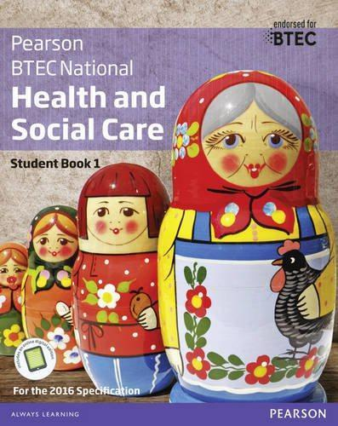
Extended Certificate only (below only)
1. Human Lifespan Development
2. Working in Health and Social Care
5. Meeting Individual Care and Support Needs.
10. Sociological Perspectives

Diploma (above and below)

4. Enquiries into Current Research in HSC
7. Principles of Safe Practice in HSC
8. Promoting Public Health
12. Supporting Individuals with Additional Needs

The textbooks that we use in school are:
- BTEC National Health and Social Care Book 1. (ISBN: 978-1292126012)

Textbooks are not mandatory but may support you in your private study periods and at home. The department has several textbooks and an e-book available for you to use at school.

If you choose to buy your own, please look around on several websites to save you money!

Our department twitter account regularly shares current research and articles that are relevant to all areas of Social Science, including HSC.
@HBKSocSci
Health and Social Care is everywhere, so you’ll be able to see aspects of it in all forms of media. Try searching for the following titles and make notes on any videos you watch; try to keep it relevant to the topics taught in Health and Social Care (see above).
- The Toddlers who took on Dementia (iPlayer)
- 24 hours in A&E / One Born Every Minute (4OD)
- Winterbourne View (sensitive content) (Youtube)
- Stacey Dooley documentaries (iPlayer/Youtube)
Make any notes from your video observations here:
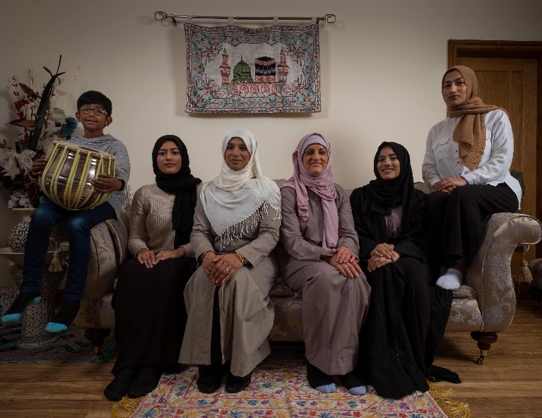
Task:
Watch ‘My Week As a Muslim’(4OD) and answer the questions below.
Why did Katie want to conduct this research? What did she find?

How did Katie have to adapt to Muslim life?

Was it necessary to produce a documentary like this? Explain why.

Are social care services improving people's wellbeing?
The Care Act has not delivered hoped-for change – but there is a way to deliver a better quality of life for older and disabled people - Mon 23 Apr 2018
If the 2014 Care Act has one widely known ambition, it is that individuals’ wellbeing should be the over-arching consideration in all that councils do. Social care should focus on what makes the lives of each older or disabled person better. So, if promoting wellbeing is the acid test of the personalisation programme, how are councils doing?
In 2016-17, a new measure was introduced. Councils had been required to survey service users annually. But how people rate their wellbeing is affected by many factors beyond a council’s control, such as the nature and severity of their condition, so NHS Digital devised a sophisticated method to control these factors, creating a measure of what it calls “the impact of adult social care”.
The scale goes from zero (“no better than being dead”) to one (“full quality of life”). The national average score was 0.4. The lowest-scoring council was Kensington and Chelsea in London at 0.29 and the highest Sandwell in the West Midlands at 0.48. It is hardly encouraging that social care is leaving people closer to feeling “no better than being dead” than having a “full quality of life”, with no council getting past the halfway point. But the “postcode lottery” in provision enables us to know more about whether the Care Act is working. If it is, we can expect councils that spend more to be improving well-being most.
Changes to the annual returns councils provide to NHS Digital mean we now know how many people each authority provides ongoing support to during the year and how much in total is spent supporting them. In 2016-17, Southend in Essex supported 3,260 people at home spending £19.1m, an average of £5,800 a person. At the other end of the scale, Wokingham in Berkshire supported 1,240 people at a cost of £24.1m, an average of £19,435 a person, almost four times as much. But Southend achieved a higher wellbeing score (0.41) than Wokingham (0.38). The 10% of highest spending councils averaged £15,930 a person and scored an average 0.4 for wellbeing; the 10% of lowest spenders spent £7,270 per person and averaged 0.39.
The figures we used relate only to those in receipt of long-term support. There are separate returns showing numbers of people getting short term support and the amount spent on them. We excluded those. This significantly reduces any anomalies that might arise from “turnover” of service users. The good news if you live in Wokingham and are eligible for public support is that you will get a far higher level of support than someone in Southend with the same level of need. The bad news is that it won’t make much difference.
These figures resonate powerfully with findings by Ipsos Mori last year. The pollsters studied data from the Health Survey for England and the English Longitudinal Study of Ageing. Researchers found that the extent to which needs were met had little impact on people’s sense of wellbeing. The problem is the conventional understanding of “need”. People are typically asked about difficulties, the routines of daily living and what they can’t do. This creates a narrow focus based on weaknesses. This has two negative consequences for wellbeing: services address deficits in a way that undermines the autonomy and resourcefulness that people treasure, and overlook needs that are more important to the person’s sense of wellbeing, such as social contact.
Given a choice, people may prefer to struggle on meeting their daily living needs and get support to meet the needs that will make their life better.
In 2014 we noted that the legislature, through the Care Act, had created the legal framework for real change. However, we warned that the government’s strategy for implementing the act would undermine its ambitions. Our advice was unheeded. It is no surprise that Jeremy Hunt, now secretary of state for care as well as health, made no mention of the Care Act in his recent overview of what needs to happen in social care. But it can still be done. Government must divest itself of the belief that personal budgets will transform social care. We have set out how that belief is illusory. Eligibility of need must be replaced with affordability of need as the means to control spending. The things that really matter to people must be the foundation of all that happens.
While the system may fall short because of resources, there will be two important changes. First is that what support is provided will be targeted on what really matters to the person. Second, the system will know the true gap between needs and resources. As the Local Government Association noted in its submission to the joint parliamentary committee inquiry into the future of social care, estimates of the funding gap fail to address needs either completely unmet or undermet.
Hunt says he wants a system that addresses the “whole person” and gives them control. Neither can happen under a system where “need” is standardised and rooted in personal deficits. It can only occur if the lived experience of need becomes the foundation of all that happens. Hunt will then have the bonus of what any progressive secretary of state for health and social care needs: knowledge of the true cost of enabling all older and disabled people to have the level of wellbeing right for them.
Outline The Care Act (2014):

What is the post-code lottery?

Summarise the article above:

The NHS in 2017
The NHS in 2017 confronts five paradoxes:
- We’re getting healthier, but we’re using the NHS more. Life expectancy has been rising by five hours a day, but the need for modern NHS care continues to grow (1). Demand for health care is highly geared to our growing and aging population. It costs three times more to look after a seventy five year old and five times more to look after an eighty year old than a thirty year old (2). Yet today, there are half a million more people aged over 75 than there were in 2010. And there will be 2 million more in ten years’ time. Demand is also heavily impacted by rising public expectations for convenient and personal care, the effectiveness of prevention and public health, and availability of social care. Even more significant is the steady expansion of new treatments and cures, of which the public are often unaware.

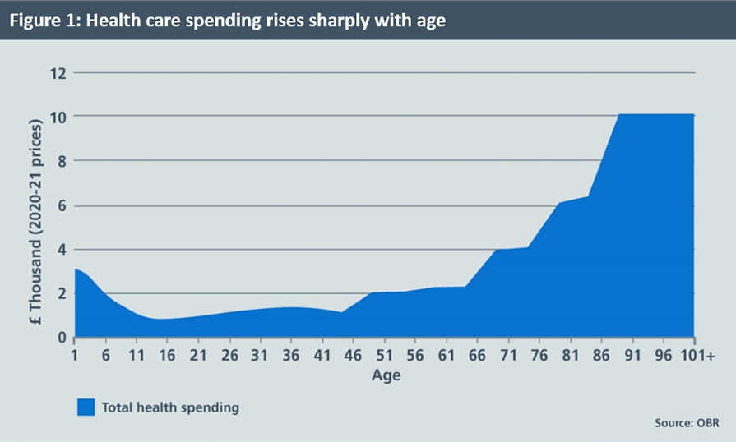
- The quality of NHS care is demonstrably improving, but we’re becoming far more transparent about care gaps and mistakes. Outcomes of care for most major conditions are dramatically better than three or five or ten years ago. Annual cancer survival rates are up (3). Heart attack and stroke deaths have tumbled (4). But greater transparency and rising expectations mean greater awareness of care gaps and variation. And although they are substantially lower than they were a decade ago, waiting times have been edging up.

- Staff numbers are up, but staff are under greater pressure. Over the two years from November 2014, there has been an increase of around 8000 more doctors and nurses working in the NHS (5) but there are still gaps in some professions and specialties. Frontline NHS staff say their experience at work continues to improve, with this year’s annual staff survey scores at a five year high (6). Yet only 52% of staff are satisfied with the opportunities for flexible working and 15% have experienced physical violence from patients, relatives or members of the public.

- The public are highly satisfied with the NHS, but concerned for its future. Perhaps surprisingly, newly published independent data spanning three decades shows that public satisfaction with the NHS is higher than in all but three of the past 30 years (7). And it reveals public satisfaction with hospital inpatients is at its highest for more than two decades. As a result The King’s Fund says that “In 2016 the NHS remained popular with the public, far more so than it was 10 or 20 years ago” (8). Looking internationally, 69% of the public in this country say they get good healthcare, compared with 57% in France and 59% in Germany, and only 47% in 22 other nations. But a higher proportion of our public are worried about the future of the NHS (9).

- There is now an underlying consensus about how care needs to change to ‘future proof’ the NHS, but the ability to do so risks being overtaken by what CQC has called today’s ‘burning platform’ (10). That’s why in Autumn 2014, in the wake of several years of contentious political and legislative debate, the NHS nationally came together – to chart for the first time its own direction for the years ahead.

Explain some of the political changes within the NHS that have happened since 2016. Have they tackled any of the 5 issues above?

What is the biomedical model of health and how does the NHS use this model?

What is the ageing population and why could this impact the economy?

Who are CQC? Explain their role in Health and Social Care:

Who are NICE? Explain their role in Health and Social Care

Who are Ofsted? Explain their role in Health and Social Care

How do these above professional bodies regulate health and social care professionals?

Discuss ways that health and social care professionals are regulated by professional bodies [8 marks]

Outline Ainsworth's theory of 'types of attachment':

Outline Bowlby’s theory of the effects of separation.

Thinking of PIES and emotional development. What are some of the effects of divorce on emotional development (positive and negative)?

Elizabeth is 48 and lives with her husband Bill who is 50. They have 2 children, Sam who is 4 and Fiona who is 15. Elizabeth and Bill have decided to divorce.
With reference to relevant theories, assess the possible effects of his parents' divorce on Sam’s emotional development [10 marks].

