NEA: STUDENT HANDBOOK

NEA: Non Examined Assessment

Exam Board: AQA
Topic: Russian Government and Society c.1856-1964

DRAFT DEADLINE: ……………………………………….
FINAL DEADLINE: ………………………………………..

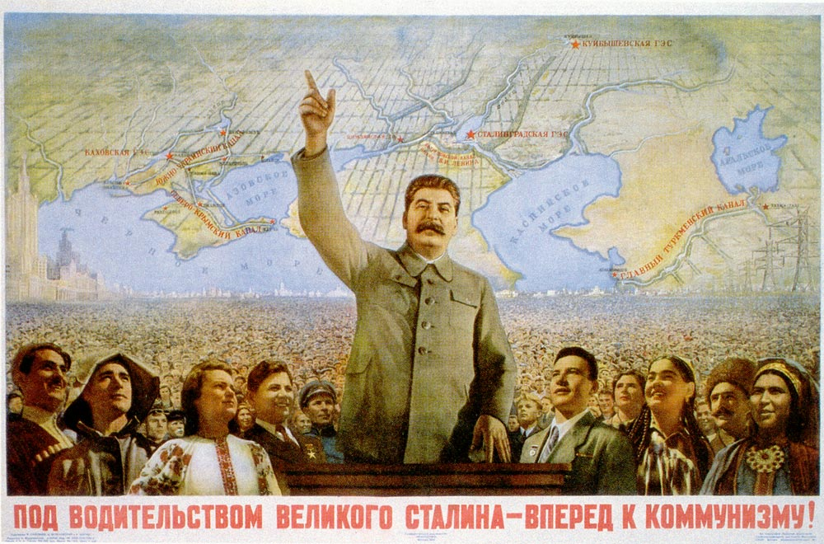

NEA: HANDBOOK CONTENTS

Pg 1……………………….Front Cover
Pg 2……………………….Contents page
Pg 3……………………….NEA: Introduction
Pg 4……………………….Basic requirements
Pg 5……………………….Subject content
Pg 6……………………….Reading list
Pg 7……………………….Assessment criteria
Pg 8……………………….Assessment criteria
Pg 9………………………. Markscheme: AO1 Knowledge & Understanding
Pg 10………………………Markscheme: AO2 Primary sources
Pg 11…………………….. Markscheme: AO3 Historical Interpretations
Pg 12………………………Student Speak Markscheme
Pg 13………………………Investigation titles

NEA: INTRODUCTION

- What is an NEA?
The NEA is an independent investigation into as aspect of civil rights of your choice. You will be taught a general overview of Russia 1856-1964 and then you will choose to focus on a particular aspect which has interested you. You will research and write an extended essay of 3,000-3,500 words. You essay must include primary sources and historical interpretations (more detail on this in another section).

- Choosing your investigation
You will be given a list of possible essay questions to choose from.

- Drafts and feedback
You will write a draft version to be handed in on the agreed draft deadline. You will receive some feedback and guidance on this draft within the limits of the NEA requirements.

- Research and footnotes
You will be expected to research your chosen investigation independently. You can use the research books in the History Base, the school library, the internet, the UEA library and the public library.

As you research you must keep a record of where your notes and quotes have come from (author, name of book, pg number). You will be expected to indicate where your information has come from by using footnotes so it is very important you keep a record of this as you go along.
NEA: KEY INFORMATION

Question | You choose from a list
Total word count | 3,000 – 3,500 words
Primary sources | At least 3
Historical interpretations | At least 2
Footnotes and bibliography | Author, name of book, date and place published, page number
Draft | 1 draft
Contribution to A Level grade | 20%

NEA: BASIC REQUIREMENTS

How to use primary sources

You must include at least 3 different TYPES of primary sources.
Eg Speech transcript, private letter/telegram, newspaper report

- Integrate the source into your answer
- Give quotes from the source
- Comment on the provenance of the source – nature, origin, purpose, typicality, comprehensives, representative
- Judge the ‘value’ of the source material

How to use historical interpretations

You must include at least 2 different Historical Interpretations related to your key issue.

- Outline the main argument of each interpretation
- Give quotes to illustrate their point of view
- Discuss the validity of the HI by comparing it to your own knowledge – ie does your own knowledge suggest the argument is an accurate interpretation? What are the limitations of their argument?
- Place the author into context:
– When were they writing and how might that affect their opinions?
–What is the purpose of their writing and how might that affect their opinions?
- Do they fit a particular school of thought?

How to include 100 years

Your investigation must take into consideration the 100 year period.

- Try to tackle the investigation in terms of themes or factors. Try to avoid a chronological approach.
- Make comparisons across the period – ie highlight similarities and differences (eg The Emancipation of the Serfs compared to Stolypin’s Land Reforms)
- Consider trends over time – ie what are the reoccurring issues?
- Consider key turning points and how these influence future events

NEA: SUBJECT CONTENT

A Few Key figures:
Alexander II
Alexander III
Witte
Nicholas II
Stolypin
Rasputin
Kerensky
Lenin
Trotsky
Stalin
Kruschev

1854-6 The Crimean War
The Accession of Alexander II
The Emancipation of the Serfs
1881Assassination of Alexander II and accession of Alexander III
1884 Russo-Turkish War
1891 The Great Famine
1896 Accession of Nicholas II
The Great Spurt
The 1905 Revolution
1904-5 The Russo-Japanese War
The October Manifesto
The Fundamental Laws
WWI 1914-17
The February Revolution
The October Revolution
The Civil War
War Communism
NEP
Death of Lenin
The power struggle
Collectivisation
The First Five Year Plan
WWII
Death of Stalin
Destalinisation

NB. This is not an exhaustive list – in fact we have deliberately left off dates and many more minor events to encourage you to explore in your private study time. However if you are stuck the list above is a pretty good place to start!

NEA: READING LIST

An excellent range of books on Russia History is available to you via the school library and masses of support including podcasts by historians can be found on our website… http://www.hinchingbrookeschool.co.uk/history/year13history.htm

The Basics:
Russia and its Rulers 1855-1964, Holland
Russia 1891-1991, Figes
Years of Change: Russia and the USSR 1851-1991, Evans and Jenkins
Communist Russia under Lenin and Stalin, Cohn and Feihn
Twentieth Century Russian History, Lowe
Some other good reads

Some Recommendations:
A People’s Tragedy, Figes
Russia 1848-1917, Bromley
Tsarist Russia 1801-1917, Hite
Reaction and Revolutions, Lynch
Stalin’s Russia, Lynch
Trotsky the Permanent Revolutionary, Lynch
Russia’s War, Overy
Imperial Russia, Waldron
Stalin , Volkogonov

Primary material and internet resources:

http://spartacus-educational.com/Russia.htm
http://heathenhistory.co.uk/russia/
http://www.historylearningsite.co.uk/modern-world-history-1918-to-1980/russia-1900-to-1939/
http://discover.odai.yale.edu/ydc/

AND do not forget …

http://www.hinchingbrookeschool.co.uk/history/year13history.htm

NEA: ASSESSMENT CRITERIA

AO1 | 50% | KNOWLEDGE AND UNDERSTANDING
AO2 | 25% | PRIMARY SOURCES
AO3 | 25% | HISTORICAL INTERPRETATIONS

AO1: KNOWLEDGE AND UNDERSTANDING (50%)
Demonstrate, organise and communicate knowledge and understanding to analyse and evaluate the key features related to the periods studied, making substantiated judgements and exploring concepts, as relevant, of cause, consequence, change, continuity, similarity, difference and significance

To meet the requirements of this Assessment Objective, students should demonstrate:
• engagement with one or more of the concepts referred to in the Assessment Objective
• effective organisational and communication skills through analysis and evaluation which consistently and relevantly focuses on the question that is set and integrates into this evaluation, primary sources and historical interpretations
• analysis and evaluation which reflects the views and conclusions of the student
• substantiated judgements, which appear as the argument develops (assertive and unsubstantiated or undeveloped judgements will not be placed in higher levels).

AO2: PRIMARY SOURCES (25%)
Analyse and evaluate appropriate source material, primary and/or contemporary to the period, within the historical context. The length of primary sources to be used is not prescribed. The skills required to interrogate primary sources to corroborate or challenge the overall response to the chosen issue may be met through primary sources of differing lengths and ones which include visual sources. Students are required to analyse and evaluate the value of three primary sources of at least two different types (as exemplified in the specification), referring, as appropriate, to provenance, content and argument and tone and emphasis.

To meet the requirements of this Assessment Objective, students should demonstrate:
• selection of sources which are directly relevant to the issue and question of the Investigation
• awareness of the value which may result from consideration of the provenance of the source, considering, for example, who the author is, when specifically it was produced, to whom and in what form it is addressed, the tone and style of the source and the content it contains.

AO3: HISTORICAL INTERPRETATIONS (25%)
Analyse and evaluate, in relation to the historical context, different ways in which aspects of the past have been interpreted. In doing so, students must demonstrate knowledge and understanding of:
• the limitations placed on historians when they develop interpretations
• the significance of the time and/or context in which a historian writes
• comparison and evaluation of differing historical interpretations.

Whilst the issue to be investigated must be placed within the context of approximately 100 years, the work and interpretations of the two historians which are studied in depth may:
• be interpretations which refer to the whole 100 years
•be interpretations that relate to a period of years, or a particular aspect, within the 100 years, but cover the same period within the 100 years
• be interpretations that relate to different periods or aspects within the 100 years context. Students must analyse and evaluate the work of two historians in depth to demonstrate the skills and knowledge but should also show a general awareness of the range of debates related to the issue.

AO1: KNOWLEDGE AND UNDERSTANDING (20 marks )
NOTE: an Historical investigation which fails to show an understanding of change and continuity within the context of approximately 100 years cannot be placed above Level 2 in AO1 (maximum 8 marks)

Level 5: 17–20 The response demonstrates a very good understanding of change and continuity within the context of approximately 100 years and meets the full demands of the chosen question. It is very well organised and effectively delivered. The supporting information is well-selected, specific and precise. It shows a very good understanding of key features, issues and concepts. The answer is fully analytical with a balanced argument and well-substantiated judgement.

Level 4: 13–16 The response demonstrates a good understanding of change and continuity within the context of approximately 100 years and meets the demands of the chosen question. It is well-organised and effectively communicated. There is a range of clear and specific supporting information, showing a good understanding of key features and issues, together with some conceptual awareness. The response is predominantly analytical in style with a range of direct comment relating to the question. The response is well-balanced with some judgement, which may, however, be only partially substantiated.

Level 3: 9–12 The response demonstrates an understanding of change and continuity within the context of approximately 100 years and shows an understanding of the chosen question. It provides a range of largely accurate information which shows an awareness of some of the key issues. This information may, however, be unspecific or lack precision of detail in parts. The response is effectively organised and shows adequate communication skills. There is a good deal of comment in relation to the chosen question, although some of this may be generalised. The response demonstrates some analytical qualities and balance of argument.

Level 2: 5–8 The response demonstrates some understanding of change and continuity but may have limitations in its coverage of a context of approximately 100 years. The response may be either descriptive or partial, showing some awareness of the chosen question but a failure to grasp its full demands. There is some attempt to convey material in an organised way although communication skills may be limited. The response contains some appropriate information and shows an understanding of some aspects of the investigation, but there may be some inaccuracy and irrelevance. There is some comment in relation to the question but comments may be unsupported and generalised.

Level 1: 1–4 The response demonstrates limited understanding of change and continuity and makes little reference to a context of approximately 100 years. The chosen question has been imperfectly understood and the response shows limited organisational and communication skills. The information conveyed is extremely limited in scope and parts may be irrelevant. There may be some unsupported, vague or generalised comment.

AO2: PRIMARY SOURCES (10 marks)

Level 5: 9–10 Provides a range of relevant and well-supported comments on the value of at least three sources of two or more different types used in the investigation to provide a balanced and convincing judgement on their merits in relation to the topic under investigation.

Level 4: 7–8 Provides relevant and well-supported comments on the value of three or more sources of two or more different types used in the investigation, to produce a balanced assessment on their merits in relation to the topic under investigation. Judgements may, however, be partial or limited in substantiation.

Level 3: 5–6 Provides some relevant comment on the value of three sources of at least two different types used in the Investigation. Some of the commentary is, however, of limited scope, not fully convincing or has only limited direction to the topic under investigation.

Level 2: 3–4 Either: provides some comment on the value of more than one source used in the investigation but may not address three sources in equal measure or refers to sources of the same 'type'. Or: provides some comment on the value of three sources of at least two types used in the investigation but the comment is excessively generalised and not well directed to the topic of the investigation.

Level 1: 1–2 Provides some comment on the value of at least one source used in the Investigation but the response is very limited and may be partially inaccurate. Comments are likely to be unsupported, vague or generalised.
In commenting and making judgements on the value of the sources, students will be expected to apply their own contextual knowledge and perspectives of time and place in order to assess the value and limitations of their sources as evidence.

They will be expected to comment on, as appropriate to the investigation and chosen sources:

• The differing perspectives of the sources chosen
• The social, political, intellectual, religious and/or economic contexts in which the sources were written
• The credibility, authority, authenticity, consistency and comprehensiveness of the sources
• The bias, distortion or propagandist elements found in the sources.

AO3: HISTORICAL INTERPRETATIONS (10 marks)

Level 5: 9–10 Shows a very good understanding of the differing historical interpretations raised by the question. There is a strong, well-substantiated and convincing evaluation of two interpretations with reference to the time and/or context and the limitations placed on the historians.

Level 4: 7–8 Shows a good understanding of the differing historical interpretations raised by the question. There is some good evaluation of the two interpretations with reference to the time and/or context and the limitations placed on historians, although not all comments are substantiated or convincing.

Level 3: 5–6 Shows an understanding of differing historical interpretations raised by the question. There is some supported comment on two interpretations with reference to the time and/or context and the limitations placed on historians, but the comments are limited in depth and/or substantiation.

Level 2: 3–4 Shows some understanding of the differing historical interpretations raised by the question. They may refer to either the time and/or context or to the limitations placed on the historians, or to both in an unconvincing way.

Level 1: 1–2 Shows limited understanding of the differing historical interpretations raised by the question. Comment on historical interpretations is generalised and vague.
In showing an understanding of historical interpretations and evaluating historical interpretations, students will be expected to apply their own contextual knowledge.

They will be expected, as appropriate to the investigation:

• To show an understanding of the limitations placed on historians
• To show an understanding of the significance of the time and/or context in which an historian writes
• To compare and evaluate differing historical interpretations.

NEA: Student Speak Mark Scheme

AO1 | KNOWLEDGE AND UNDERSTANDING | - 100 year period properly considered  - Clear structure and organisation  - Strong focus on ‘change and continuity’  - Well selected and precise information  - A fully analytical approach (no description)  - Offers a balanced argument  - Provides well-supported judgements
AO2 | PRIMARY SOURCES | - Makes use of 3 different ‘types’ of sources  - Explicitly analyses the N.O.P of 3 sources  - Reaches a judgement on the ‘value’ or ‘merits’ of 3 sources in relation to the investigation
AO3 | HISTORICAL INTERPRETATIONS | - Makes use of 2 different historical interpretations  - Evaluates the interpretations based on how convincing the interpretation is  - Considers the context that the historian was writing in and how this might affect their interpretation  - Considers the purpose of the historian and how this might affect their interpretation  - Considers the limitations placed upon the historian

NEA: INVESTIGATION TITLES

THE IMPACT OF WAR:

- How far is it fair to say that ‘war was the main factor for destabilising Russian government and society’ in the period 1856-1956?
- To what extent was war the most significant driving force in creating political change in Russia 1856-1956?

LEADERSHIP AND CONTROL:

- How far is it fair to say that Stalin was by far the most repressive Russian leader in the period 1856-1956?
- How far is it fair to say that Alexander II was by far the most liberal of Russia’s leaders in the period 1856-1964?
- To what extent was repression the main means of political and social contol in Russia in the period 1856-1964?
- ‘The failure to break away from autocractic and dictatorial rule in Russia was the result of weak opposition’ How far is this view valid with reference to the period 1855-1953?
- How far was political ideology the most significant reason why Russia’s leaders resorted to authoritarian rule in the period 1856-1964?
- ‘Lenin had the greatest influence on the nature and development of Russian government and society in the period 1856-1964’ How far do you agree?

ECONOMY AND SOCIETY:

- To what extent did the Famine of 1891 have the most significant impact of the development of Russian Government and Society in the period 1856-1964?
- How far was Russian socio-economic backwardness the most significant force driving social and economic reform in the period 1856-1964?
- ‘The Emancipation of the Serfs had the greatest impact on the development of Russian Government and Society in the period 1856-1964’ How far do you agree?

Exemplar Material

You can find a sample answer on the AQA website by following this link:
(please note that the sample answer is on a different historical topic to the one you will be writing on!)

http://filestore.aqa.org.uk/resources/history/AQA-7042-NEA-TSD-ANS.PDF

