Edexcel History GCSE – Medicine Through Time, c1250 – Present
Revision Booklet
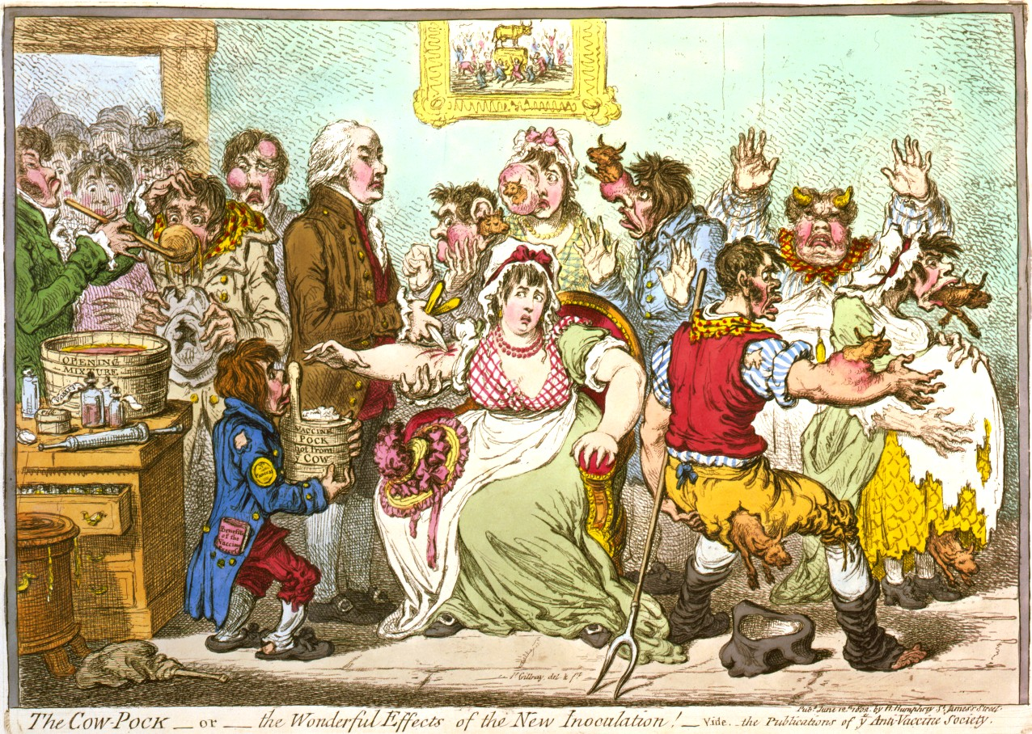

This booklet includes:
- Personal Learning Checklist
- Key Individual Tables
- Content Mind-Maps
- Timelines
- Exam-Style Questions & Structures
Please note that this is not the only thing you should use to revise – be sure to use notes and sheets from class, in addition to your own research and example papers.
Also, this booklet does not include the information on the First World War source questions – please use specific summer task booklet for that topic.

Medicine Through Time, c1250 - Present
Personal Learning Checklist
 | R | Steps to improve… | A | Steps to improve… | G
Topic 1:
Medicine in Medieval England, c1250 - c1500
Cause
Prevention
Treatment
Individuals
Case Study: The Black Death
Topic 2:
The Medical Renaissance in England, c1500 – c1700
Cause
Prevention
Treatment
Individuals
Case Study: The Plague
Topic 3:
Medicine in 18th and 19th Century Britain
Cause
Prevention
Treatment
Individuals
Case Study: Cholera, 1854
Topic 4:
Medicine in Modern Britain, c1900 - Present
Cause
Prevention
Treatment
Individuals
Case Study: Lung Cancer
Topic 1: Medicine in Medieval England, c1250 – c1500

Key Individuals
Individual | Description
Hippocrates
Galen

Origins of the Theory | The Four Humours  1.  2.  3.  4.
Link to Seasons | Popularity  The Four Humours
Causes

God | Magic  Other Causes
Astrology  : | Miasma

Causes
The Church |  | Literacy  Understanding of Causation
Consideration of  Alternatives  :  Causes |  | Printing Press
The Church | Hygiene
Diet  : | Purity of Air  Preventing Disease
Prevention

Mass | Pilgrimage
Fasting  : | Prayers & Spells  Religious Treatments
Treatment
Astrology | Blood-Letting (Phlebotomy)  Alternative  Treatments
Purging & Bathing | Herbal Remedies
Treatment
 | Physicians | Apothecaries | Surgeons
Background
Positives
Negatives

 | Hospitals | Home Care
Positives
Negatives
Treatment
The Black Death
Background to the event:

What role did the government play in the disaster?
 | Cause | Prevention | Treatment
Religious
Astrology
Natural

Case Study

1500
1500
1500

Medicine in Medieval England, c1250 - c1500

1250
1250
Topic 2: The Medical Renaissance in England, c1500 – c1700

Key Individuals
Individual | Description
William Harvey
Thomas Sydenham
Robert Hooke
Andreas Vesalius
King Charles II
What factors aided these individuals?
- Technology?
- Science?
- Religion?
- Society?
- Institutions?

 | Medieval View | Renaissance View | Extent of Change?
Four Humours
Anatomy (Human Body)
Urine

The Church

Superstition

Miasma

Causes
Origins | Aims
Methods & Research | Publications  The Royal Society

Causes
What difference did the “Barometer” and “Thermometer” make?
 | Medieval  View | Renaissance View | Extent of Change?
Prayer
Hygiene
Miasma
Prevention

Transference | Four Humours
Herbal Remedies  Old:  New:  Consider: What was happening at the time to make new remedies available? | Chemical / Alchemy  Renaissance  Treatment

Treatment
 | Medieval Role | Renaissance Role
Hospitals

Home Care

Consider: What event during the reign of Henry VIII greatly impacted on hospitals?
Treatment

Astrology | Religion
Miasma | People  Great Plague: Causes

Case Study

Religion | Government Action
Plague Doctors | Natural Prevention  Great Plague: Prevention  Diet:  Pomanders:

Case Study
Quarantine | Transference
Quack Doctors | Avoidance  Great Plague: Treatment

Case Study

Topic 3: Medicine in 18th and 19th Century Britain
The Medical Renaissance in England, c1500 – c1700
1500
1700

Key Individuals
Individual | Description
Louis Pasteur
Joseph Lister
Robert Koch
Florence Nightingale
James Simpson
Edward Jenner
John Snow
What factors aided these individuals?
- Technology?
- Science?
- Religion?
- Society?
- Institutions?

Four Humours | Miasma  Causes of Disease
Spontaneous Generation | Germ Theory  Louis Pasteur:  Theory:  Impact:
Causes
Origins of Research  : | Discovery  Robert  Koch
Cholera | Impact

Causes

Causes
Technology | Society
Science | Individuals  Understanding of Causation

 | Edward Jenner | Joseph Lister
Research
Impact
Opposition

Prevention
 | 1848 Public Health  Act | 1875 Public Health Act
Motivation
Impact
Opposition

Prevention

Prevention
Hospitals | Crimean War
Reforms | Impact  Florence Nightingale

Treatment
 | Anaesthetic | Chloroform
Key Individuals
Research
Impact
and Opposition

Treatment
The 1854 Epidemic | John Snow
Prevention and  Impact | Opposition  Cholera Epidemic, 1854

Case Study

1087
1900

Medicine in 18th and 19th Century Britain

1700
Topic 4: Medicine in Modern Britain, c1900 - Present

Key Individuals

Individual | Description
Francis Crick & James Watson
Rosalind Franklin & Maurice Wilkins
Alexander Fleming
Howard Florey & Ernst Chain

X-Rays  Franklin & Wilkins:  Crick & Watson: | Technology
Science | I Impact  Genetics

Causes
Smoking | Diet
Alcohol | Skin Care  Lifestyle  &  Health

Causes
Blood Tests | Technology  X-Ray:  CT Scans:  Ultrasound:  MRI Scans:
ECGs | I Endoscopes  Diagnosis

Causes

 | Vaccinations | Government
Motivation

Positives

Negatives

Key Examples

Prevention

Magic Bullets | Antibiotics
Science | I Technology  Chemical  Treatment

Treatment
Access to Treatment | Methods of Treatment
The NHS
Treatment
What was happening at the time to aid the creation of the NHS?
Alexander Fleming | Florey & Chain
Development | I Impact  Penicillin
What was happening at the time to aid the development of the new “wonder drug?”

Treatment

Diagnosis | Treatment  Transplants:  Radiotherapy:  Chemotherapy:
Government Action  Persuasion:  Enforcement: | I Impact  Lung Cancer  Pharmacogenomics:

Case Study

Medicine in Modern Britain, c1900 - Present

1900
1900
Practice Questions

Topic 1: Medicine in Medieval England, c1250 – c1500

12 marks
- Explain why there was continuity in ideas about the cause of disease during the period c1250 – c1500. You may use the following information in your answer: The Church and Galen. You must also use information of your own.
- Explain why there was little change in the care provided by hospitals in the period c1250-c1500. You may use the following information in your answer: Ideas in the Church and Herbal Remedies. You must also use information of your own.

16 marks (20 with SPAG)
- ‘Hospital treatment in England in the period from 1250 to 1500 was very rare.’ How far do you agree? You may use the following information in your answer: Charity Hospitals and Care in the Home. You must also use information of your own.
- ‘Medical treatments and preventions during the Medieval period were based on religion and superstition.’ How far do you agree? You may use the following in your answer: Bloodletting and Purging and Praying and Fasting. You must also use information of your own.

Topic 2: The Medical Renaissance in England, c1500 – c1700

4 marks
- Explain one way in which ideas about the cause of disease and illness were similar in the 14th and 17th centuries.
- Explain one way in which ideas about the treatment of disease were different in the 17th century from ideas in the 13th century.
- Explain one way in which ideas about preventing the plague were different in the 14th and 17th centuries.

12 marks
- Explain why there were changes in the way ideas about the causes of disease and illness were communicated in the period c1500 – c1700. You may use the following in your answer: The Printing Press and The Royal Society. You must also use information of your own.
- Explain why there was continuity in the way disease was treated in the period c1500 – c1700. You may use the following information in your answer: The Great Plague and Attitudes in Society. You must also use information of your own.

16 marks (20 with SPAG)
- ‘Individuals had the biggest impact on medical training in the 16th and 17th centuries.’ How far do you agree? You may use the following information in your answer: Vesalius and The Printing Press. You must also use some information of your own.

Topic 3: Medicine in 18th and 19th Century Britain
4 marks
- Explain one way in which attempts to prevent disease were different in the 17th and 19th centuries.
12 marks
- Explain why there was rapid change in surgical treatments in the period c1700 – c1900. You may use the following in your answer: Chloroform and Joseph Lister. You must also use information of your own.
- Explain why there was rapid change in the prevention of smallpox after 1798. You may use the following information in your answer: Inoculation and The Government. You must also use information of your own.
- Explain why there was rapid change in surgery during the 19th century. You may use the following in your answer: Joseph Lister and Anaesthetics. You must also use information of your own.
- Explain why there was rapid change in the understanding of the cause of disease c1700 – c1900. You may use the following in your answer: Germ Theory and Robert Koch. You must also use information of your own.
16 marks (20 with SPAG)
- ‘There was rapid change in ideas about the causes of illness and disease in the period c1700 – c1900.’ How far do you agree with this statement? You may use the following information in your answer: Spontaneous Generation and Louis Pasteur. You must also use information of your own.
- ‘Louis Pasteur’s publication of the Germ Theory was the biggest turning point in medicine in the period c1700 – c1900.’ How far do you agree with this statement? You may use the following information in your answer: Edward Jenner and Robert Koch. You must also use information of your own.
- ‘John Snow’s work linking water with the spread of cholera led to major breakthroughs in preventing the spread of disease.’ How far do you agree? You may use the following information in your answer: The Broad Street Pump, Soho and The Public Health Act, 1875. You must also use information of your own.
Topic 4: Medicine in Modern Britain, c1900 - Present

4 marks

- Explain one way in which understanding of the cause of disease and illness was different in 1750 from the present day.

12 marks
- Explain why there was rapid progress in disease prevention after c1900. You may use the following in your answer: Government Intervention and Vaccinations. You must also use information of your own.

16 marks (20 with SPAG)

- ‘Treatment of diseases and care of the sick completely changed after c1800.; How far do you agree with this statement? You may use the following in your answer: Magic Bullets and the NHS. You must also use information of your own.
- ‘There has been huge progress in the prevention of disease since 1900.’ How far do you agree? You may use the following in your answer: Government Intervention and Genetic Conditions. You must also use information of your own.

Exam Structure

4 Mark Question: Describe two features of…

4 Mark Question: Explain one what in which… was similar to /
different from…

12 Mark Question: Explain why…

16 Mark Question: How far do you agree? (+4 SPAG marks)

First World War Source Questions

4 Mark Question: How could you follow up Source… to find out more about…?

8 Mark Question: How useful are the sources for an enquiry into…?

