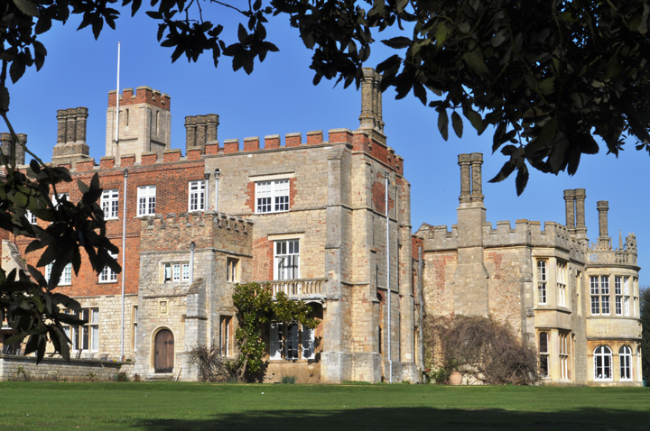

This is your summer menu to support your transition from AS to A2:

Main courses are compulsory.

Choose activities from the starter and dessert menus to enrich and develop your understanding ready for A2.

Dessert

Go to see a Shakespeare Tragedy:

Othello 28th July – 16th August Trinity College Gardens

The Merchant of Venice 28th July – 23rd August Robinson College Gardens

Visit the National Theatre’s King Lear webpage. Watch the related content clips.

Starter

Read ‘A Thousand Acres’ by Jane Smiley. This is a modern retelling of the King Lear story. There is also a DVD.

Read ‘Lear’ by Edward Bond. Another modern retelling of the King Lear story.

Listen to Radio 4s ‘In Our Time’ discussion on King Lear. Simply enter ‘In our Time’ into Google and scroll through the range of podcasts.

Watch King Lear on DVD or even better, a live production.

Mains

King Lear: Shakespeare

The White Devil: Webster

The Wife of Bath’s Prologue and Tale: Chaucer

Read the texts which you are going to study for your coursework.

ENGLISH LITERATURE A2