AS Easter Homework 2017

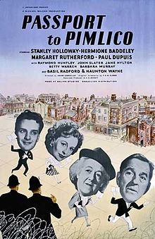
You should use the Stephanie Muir Book on Ealing, particularly chapters 3 & 7 to answer the following questions. You should expand your answers by gathering information from different parts of the relevant chapters, rather than just from page. You can also use other sources to build your answers as independent research.

1) What was Michael Balcon’s vision of England and how did Ealing films reflect this? Give examples from what you have seen so far?
2) In what way did Balcon shape the films that Ealing produced, given that he was not a screenwriter or director?
3) Ealing is variously described as a having a ‘team spirit’, a ‘family business’ and having a ‘round table approach’. What does all this mean? Give examples of the organisation at Ealing that led to this. How do you think this affected the films that the studio produced?
4) How important was T. E. B Clarke in defining the characteristics associated with Ealing films?
5) Is it fair to say that films not written by Clarke also include key characteristics associated with the studio? Why/not?
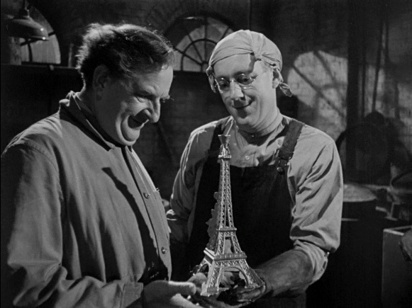
6) To what extent does Passport to Pimlico express messages and values about a) the British character and b) a post-war political vision of Britain?
7) What characteristics does The Lavender Hill Mob share with Passport to Pimlico in style and structure?

