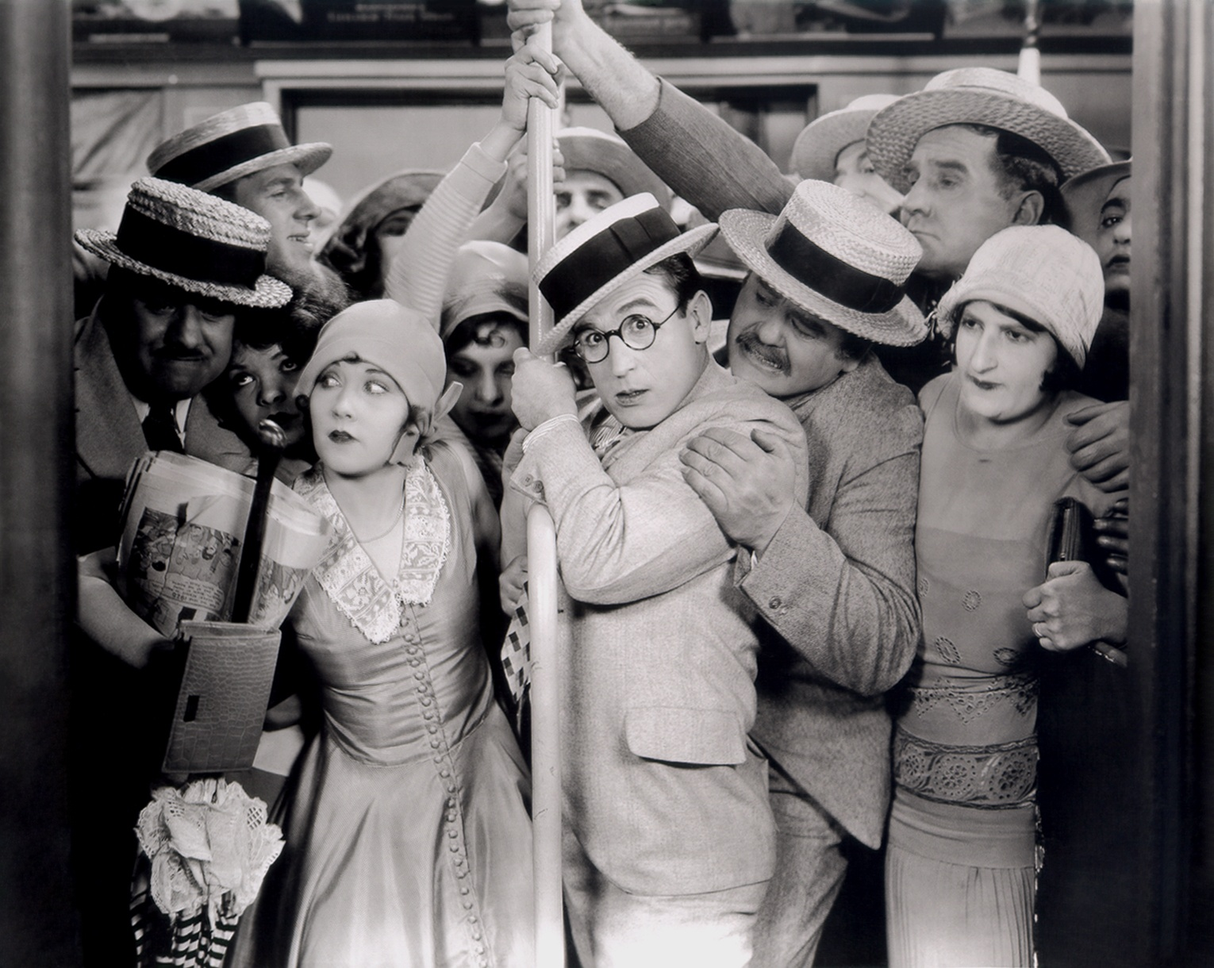

The two main characters are central in the shot
The lighting highlights the two main characters
The other actors look grumpy and oppressive
The edges of the shot include the doors of the train to add to the ‘hemmed in’ effect
Harold and his girlfriend are positioned slightly lower, making them seem vulnerable
The two main characters are wide-eyed, making them look child-like. Harold looks straight to the camera and gains eye contact with the audience
Analysing a shot
Harold Lloyd in Speedy, 1929
Harold’s hat is cocked to one side, making him look uncomfortable and comic
The central pole squashes the scene even further and lets the other actors position their hands over Harold’s head, making him more vulnerable
In 1929 Harold was already well known for playing vulnerable and likeable characters

