**Hinchingbrooke School**

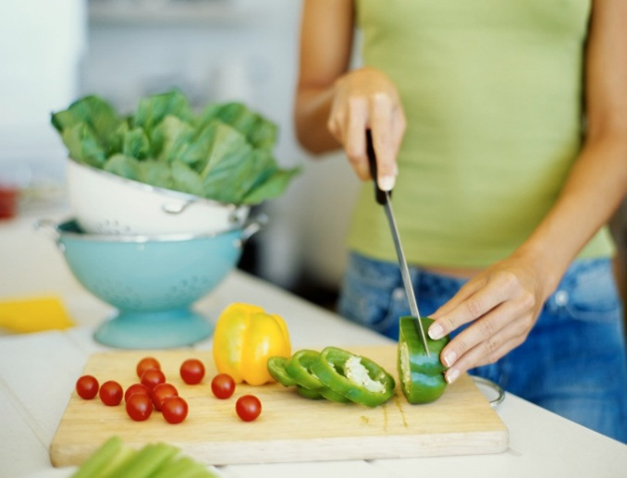

Year 7 Recipes

2015-16

|  |  |
| --- | --- |
| http://designandtechnology.weebly.com/uploads/4/6/3/4/4634986/3685358_orig.jpg?78 | **1 Star Chef**  **Award** |

Name: _____________________________________ Form:____________

Food Teacher: ___________________

What is this Scheme of Work about?

In Food you will design and make healthy meals from food. In this unit we want to introduce you to learn lots of different cooking skills so that you become confident in designing and making meals. There is an emphasis on savoury foods and understanding the sensory and functional properties of ingredients (raising agents and starches such as flour and pasta).

**Making Activity** **1: Cheesy Triangles**

**DON’T FORGET A CONTAINER TO TAKE THEM HOME**

**Date: _______________________________**

**Learning Objectives**

By the end of this activity you should be able to:-

* weigh and measure ingredients accurately
* prepare ingredients, eg peeling, chopping and grating
* use the **rubbing in technique** to make pastry
* roll out pastry to correct thickness
* use the oven safely

|  |  |  |
| --- | --- | --- |
| **Ingredients** | **Equipment** |  |
| 50g Cheddar cheese | Weighing scales | Flour dredger |
| ½ small onion | Chopping board | Rolling pin |
| 50g plain white flour | Grater | Spoon |
| 50g plain wholemeal flour | Knife | Fork |
| 50g butter or margarine | Mixing bowl | Small bowl |
| 2-3x15ml spoons cold water | Sieve | Baking tray |
| 1 egg for glazing (from school) | Measuring spoons | Palette knife |
|  |  |  |

**Method**

1. Preheat the oven to 180oC.
2. Prepare the cheese and onion filling - Grate the cheese, slice the onion. Mix cheese and onion together.
3. Make up the shortcrust pastry.
   1. Sift the flour into the bowl.
   2. Rub the butter or margarine into the flour using your fingertips, until it resembles breadcrumbs.
   3. Add the cold water and start to mix together.
   4. Mix to form a firm, smooth dough.
4. Roll out the pastry into a square on a floured surface, cut the square into quarters using palette knife.
5. Spoon some cheese filling in the middle of the square.
6. Brush the edges of the pastry with beaten egg.
7. Fold over each pasty and pinch them together all the way along.
8. Brush each pasty with beaten egg and transfer them onto the baking tray.
9. Bake for 20 minutes, until golden brown.

Nutritional Information

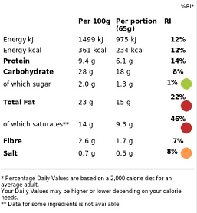

|  |  |  |
| --- | --- | --- |
| **Skills** |  |  |
| Weighing/ measuring | Knife Skills | Claw grip/Bridge hold |
| Combining | Rolling Out | Using the oven |
| Rubbing in Method | Glazing |  |

**Making Activity** 2: FruitSalad**

**DON’T FORGET A LIDDED WATERTIGHT CONTAINER TO TAKE THIS HOME**

**Date: _______________________________**

**Learning Objectives**

By the end of this activity you should be able to:

* prepare ingredients, eg slicing, dicing, peeling
* use a knife safely

**Ingredients**

200ml Fruit Juice

Choose **one** fruit from **each** column below to create a colourful fruit salad as a dessert or part of a healthy lunchbox.

* Red
* Yellow
* Orange
* Green

|  |  |  |  |
| --- | --- | --- | --- |
| **Red** | **Yellow** | **Orange** | **Green** |
| Apple | Pineapple | Satsuma | Apple |
| Strawberries | Starfruit | Orange | Pear |
| Cherries | Nectarines | Apricots | Grapes |
| Grapes | Peaches | Mango | Kiwi |
| Watermelon | Melon | Mandarins | Greengages |
| Plums | Plums | Sharon Fruit |  |

If you leave the fruit salad like this some of the fruit might go brown so we use a juice to help stop this. You can choose any flavour pure fruit juice you like, eg. orange, apple, tropical etc.

**Method**

1. Open the juice and pour in the container you are taking it home in.
2. Prepare the fruit according to the type. This could include washing, peeling, slicing, coring, or chopping.
3. The pieces of fruit should be small enough to fit more than one piece on a dessertspoon.
4. Place the fruit in the juice and stir until covered with juice.

Nutritional Information



|  |  |  |
| --- | --- | --- |
| **Skills** |  |  |
| Chopping/Knife skills | Combining | Blending |

**Making Activity** 3:** **Pasta Salad**

**DON’T FORGET A CONTAINER TO TAKE THIS HOME**

**Date: _______________________________**

**Learning Objectives**

By the end of this activity you should be able to:

* prepare ingredients, eg slicing, dicing, peeling
* use a knife safely
* cook Pasta

|  |  |
| --- | --- |
| **Ingredients** | **Equipment** |
|  |  |
| 100g pasta shapes | Weighing scales |
| 1 carrot | Saucepan |
| 100g cooked sliced chicken | Chopping board |
| Small tin of sweetcorn | Knife |
| 1 tomato | Vegetable peeler |
| ¼ cucumber | Grater |
| 2 x tablespoons low fat mayonnaise | Tablespoon |
|  | Colander |
|  |  |

**Method**

1. Put a saucepan of water onto boil. When boiling add the pasta and simmer for about 8-10 minutes or until the pasta is al dente (tender).
2. While the pasta is cooking, prepare the other ingredients:  
   slice the tomato, chop the cucumber into small chunks, peel and grate the carrot.
3. Once the pasta is cooked drain the boiling hot water away into the sink using a colander. Cool the pasta by rinsing it under a cold tap for a few moments. Drain well.
4. Place the pasta and all the other ingredients in the serving dish and stir in the mayonnaise.

**Top tips**

* Vary the type of pasta and/or vegetables used.
* Why not add some fruit, seeds or nuts?
* Instead of cooked chicken, why not go for sliced ham, grated cheese, canned tuna, slices of boiled egg, or red kidney beans?

Nutritional Information

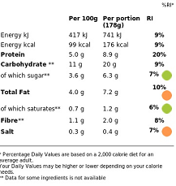

|  |  |  |
| --- | --- | --- |
| **Skills** |  |  |
| Weighing | Grating | Peeling |
| Chopping/Knife skills | Claw Grip | Bridge Hold |
| Using the Hob | Boiling/Simmering | Draining |

**Making Activity 4: Savoury Muffins**

**DON’T FORGET A CONTAINER TO TAKE THEM HOME IN**

**Date: _______________________________**

**Learning Objectives**

By the end of this activity, you should be able to:

* weigh and measure ingredients accurately
* use the **all-in-one method** to combine ingredients into a uniform batter
* divide the batter equally between cases
* use the oven safely
* understand the role of raising agents in food production

**Ingredients Equipment**

1 small or ½ large Courgette 6 muffin cases, muffin tin

60g Cheddar Cheese chopping board, knife

150g Self Raising flour grater, measuring jug

100ml Semi-skimmed Milk mixing bowl, wooden spoon

1 Egg 2 spoons, cooling rack

30ml Oil ***(from school)***

1 tsp Salt & Black pepper ***(from school)***

**Method**

1. Preheat the oven to 200oC Place the muffin cases in the muffin tin.
2. Cut the ends off the courgette and grate.
3. Grate the cheese.
4. Mix all the ingredients together with a wooden spoon to form a smooth batter.
5. Divide the mixture equally between the muffin cases using 2 spoons.
6. Bake for 25 minutes, until golden.
7. Allow to cool on a cooling rack.

Nutritional Information



**Top tips**

* Try using a grated carrot instead of courgette;
* Add finely sliced chilli or ginger for a different flavour;
* Crumble in a little crispy grilled bacon.

|  |  |  |
| --- | --- | --- |
| **Skills** |  |  |
| Weighing/ measuring | Knife Skills | Claw grip/Bridge hole |
| Grating | Dividing | Using the oven |
| Combining/ Mixing |  |  |

**j0407734[1]**

**What makes the muffins rise?**

In order for flour mixture to rise and have a light texture a raising agent must be added.

Cakes and muffins use self-raising flour which is plain flour with baking powder added. Baking powder is a chemical raising agent which reacts with liquid when it is heated. The reaction causes bubbles of carbon dioxide gas to expand inside the mixture and this causes the mixture to rise.

**Making Activity 5: Fruity Cupcakes**

**DON’T FORGET LIDDED CONTAINER TO TAKE THEM HOME IN**

**Date: _______________________________**

**Learning Objectives**

By the end of this activity you should be able to:

* weigh and measure ingredients accurately
* use the **creaming method** to make cakes
* divide the batter equally
* use the oven safely

|  |  |
| --- | --- |
| **Ingredients** | **Equipment** |
|  |  |
| 50g self raising flour | Weighing scales |
| 50g caster sugar | Mixing bowl |
| 50g soft margarine | Sieve |
| 1 egg | 6 cake cases |
| 30g dried fruit, e.g. sultanas | Cupcake Tin |
|  | Wooden spoon, metal spoon |
|  | Cooling rack |

**Method**

1. Preheat the oven to 180 oC.
2. Place the cake cases in the cupcake tin.
3. In a mixing bowl cream the margarine and sugar together until light in colour.
4. In a small basin beat the eggs with a fork.
5. Add the beaten eggs a little at a time to the sugar and margarine mix.
6. Sieve the flour and add gradually with the dried fruit to the egg, margarine and sugar mix.
7. Divide the mixture equally between the cake cases using a teaspoon.
8. Bake in the oven for 15 – 20 minutes, until golden. (They are cooked if they spring back when pressed with your fingertips).

Take out of the oven and place on a cooling rack to cool.

**Top tips**

Nutritional Information

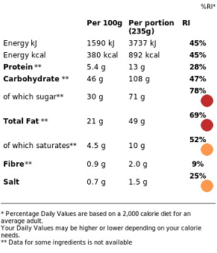

* Use different types of dried or fresh fruit,   
  e.g. dried apricots, fresh banana.
* Try adding a little spice, such as cinnamon or ginger.

|  |  |  |
| --- | --- | --- |
| **Skills** |  |  |
| Weighing/ measuring | All in one method | Combining/ Mixing |
| Dividing | Using the oven |  |
|  |  |  |

**Making Activity 6: Choose From Either –**

**Burgers**

**DON’T FORGET A LIDDED CONTAINER TO TAKE THEM HOME**

**Date: _______________________________**

**Learning Objectives**

By the end of this activity you should be able to:

* prepare ingredients eg, peeling, dicing
* use a knife safely
* be confident in handling raw meat

|  |  |
| --- | --- |
| **Ingredients** | **Equipment** |
| 250g minced beef, chicken, pork or lamb | Knife |
| 1 small red onion | Chopping Board |
| Herbs or spices to suit taste, eg Chilli powder, mixed herbs, sage, ground cumin | Mixing Bowl |
| 1 egg | Blender |
| 1 slice bread |  |
| 1 burger bun and lettuce leaves to serve |  |

**Method**

1. Peel and finely chop the onion
2. Put the meat in a large mixing bowl and add the chopped onion and seasoning.
3. Using a blender make breadcrumbs. Be careful of the sharp blades.
4. Add the egg and breadcrumbs to the bowl with a pinch of salt and pepper
5. Get your clean hands in there and really scrunch and mix everything together
6. Divide your burger mix into eight equal pieces, then pat and shape each one into a nice fat burger – you want them about 8cm wide and 3cm thick
7. Place burgers on the grill pan and put it on a high heat.
8. Cook for 10 to 12 minutes, or until cooked through, turning occasionally
9. While they’re cooking, halve your burger buns.

Nutritional Information (Burger Only)

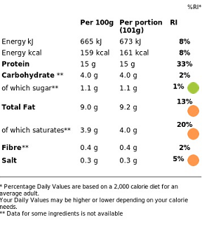

Top Tip

* You could also add something to give more flavour,   
  eg dried apricots with pork.

|  |  |  |
| --- | --- | --- |
| **Skills** |  |  |
| Chopping | Blending | Handling raw meat |
| Dividing | Shaping | Grilling |

**Making Activity Choose From Either –**

**OR Spicy Bean Burgers**

**DON’T FORGET A LIDDED CONTAINER TO TAKE THEM HOME**

**Date: _______________________________**

**Learning Objectives**

By the end of this activity you should be able to:

* prepare ingredients eg, peeling, dicing
* use a knife safely

|  |  |
| --- | --- |
| **Ingredients** | **Equipment** |
|  |  |
| 1 slice of bread | Knife |
| 1 x 400g can red kidney beans | Chopping Board |
| 1/2 onion | Mixing Bowl |
| 1 medium green chilli | Food Processor |
| 1 x 5ml spoon ground chilli powder | Can Opener |
| 1 x 5ml spoon dried herbs | Flour Dredger |
|  |  |

**Method**

1. Preheat the grill.
2. Using a blender make breadcrumbs. Be careful of the sharp blades.
3. Pour these crumbs into the mixing bowl.
4. Cut away the top of the chilli, and then de-seed.
5. Peel the onion.
6. Drain the red kidney beans.
7. Place the red kidney beans, onion, chilli, chilli powder and dried herbs into the food processor. Blitz together to form a thick paste-like mixture.
8. Place the bean mixture into the mixing bowl with the breadcrumbs. Mix everything together thoroughly.
9. On a lightly floured chopping board, divide and shape the bean mixture into 8 small patties.
10. Grill the patties for 8 minutes, turning over after 4 minutes.

Nutritional Information

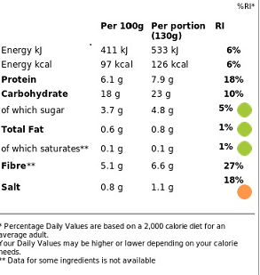

|  |  |  |
| --- | --- | --- |
| **Skills** |  |  |
| Chopping | Food Processing |  |
| Dividing | Shaping | Grilling |