AQA History – USA 1865 – 1975: The Making of a Superpower
AS Revision Booklet
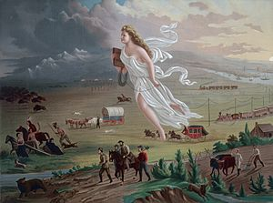

This booklet includes;
- Personal Learning Checklists (Skills and Content)
- Content Mind-Maps
- Timelines
- Exam-Style Questions
Please note that this is not the only thing you should use to revise for the summer exam – be sure to use notes and sheets from class, in addition to your own research and example papers.
USA 1865 – 1975
(The Making of a Superpower)
Personal Learning Checklist

Skills Checklist
 | R | Steps to Improve… | A | Steps to Improve… | G
Use the introduction to identify the themes / factors of the question.
Use the introduction to set the question’s context.
Signpost each factor clearly, showing how it links to the question.
Use paragraphs to organise points.
Use an appropriate structure.
Use appropriate language to write in a controlled, coherent way.
Analyse a range of factors to ensure a balanced argument.
Recall and use relevant, accurate facts and examples from my own knowledge.
Support all points with well-selected, precise and detailed evidence from all given extracts.
Link points back to the question before asked.
Weigh the evidence before reaching my conclusion.
Reach an evaluative judgement that directly answers the question.
Clear argument throughout the essay.

Exam Technique Target:
Target Grade: |  | Current Grade:
Content Checklist
 | R | Steps to Improve… | A | Steps to Improve… | G
Topic 1: The Era of Reconstruction, 1865-1877
The American Civil War (Causes/Events/Interpretations)
The Presidents of Reconstruction (Lincoln/Johnson/Grant)
Interpretations of Reconstruction (Success? Failure?)
Impact on African Americans (Impact of War/The Vote/Ku Klux Klan)
Economic and Industrial Growth (Impact of War/Population/Railway)
Native Americans (Westward Expansion/Manifest Destiny/Homesteaders/Railway/Gold Rush)
Topic 2: The Gilded Age, 1877-1890
The Presidents of the Gilded Age (Hayes/Garfield/Arthur/Cleveland)
Economic Growth (Robber Barons / Technology)
The Rise of Organised Labour (Trade Unions / Strikes)
Immigration (Push & Pull Factors/ Reactions / Nativism)
Impact on African Americans (Migration / Jim Crow Laws & Segregation / Education)
Native Americans (The Dawes Act / Wounded Knee)
The American West (The Railway / Agriculture / Cattle / Cowboys / End of the Frontier)
Topic 3: Populism and Progressivism. 1890-1912
Populism (Emergence / Members / Aims / Populist Party)
Progressivism (Emergence / Diverse Aims)
The Presidents (Roosevelt / Taft / Wilson) [Successes/Failures? Aims? Opposition? Progressive?]
Economic and Social Change (Industrial Growth / The 1893 Depression / Unions & Strikes)
Immigration (Impact / Reactions)
Impact on African Americans (Segregation / Voting)
Topic 4: Foreign Policy, 1912-1930
USA Foreign Policy (Aims / Motivation / Interpretations)
Isolationism 1865-77? (Case Studies / Examples)
Expansionism 1865-77? (Case Studies / Examples)
Gilded Age Foreign Policy (Isolationist? Key Examples?)
Progressivist Age Foreign Policy (Imperialistic? / War with Spain / Latin America / The Far East)
World War One (Role of Wilson / Motivation / Popular Reaction)
Topic 5: The Return to Normalcy, 1919 - 1932
Domestic Policies (Harding/Coolidge)
Economic Boom (Causes / Examples)
The ‘Jazz Age’ (Women / Entertainment / Prohibition)
The Wall Street Crash & The Great Depression (Causes / Impact)

The Era of Reconstruction, 1865 – 1877

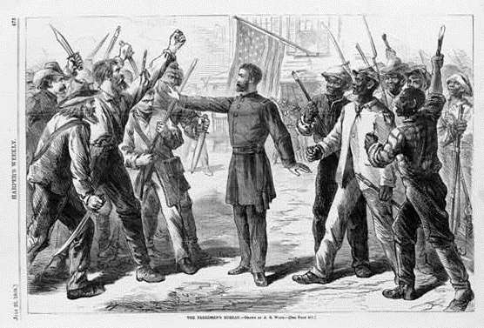
Reconstruction, which followed the Civil War, dominated this period. Three successive presidents – Lincoln, Johnson and Grant – all tried various solutions to the problems caused by the Civil War and, particularly, the issue of how to deal with the defeated Southern States. This caused deep divisions between each of the presidents and Congress, especially over the treatment of the ex-slaves. In addition, during this period, due to a combination of factors, there was dramatic economic growth particularly of industry in the USA. Successive US governments also encouraged further expansion westwards which, in turn, threatened the lifestyle of the Native Americans, especially on the Plains. American foreign policy was dominated by the policy of isolationism, although the USA did acquire Alaska from Russia.
Political System +/- | Economy +/-  Pre - Civil War Society
North-South Divide | Slavery
Causes (North) | Causes (South)  The Civil War
Main Events (North) | Main Events (South)

 | President Lincoln | President Johnson | President Grant
Aims and Motivations
Presidency
(Popularity and
Scandals)
Support
Opposition
Legislation

Political +/- | Economic +/-  Reconstruction
African Americans +/- | North-South Divide +/-

Urbanisation | Agriculture  Economic Growth
Technology & Transport | Role of Government

Westward Expansion (Motivation) | Legislation +/-  Native  Americans
Reservations | Resistance

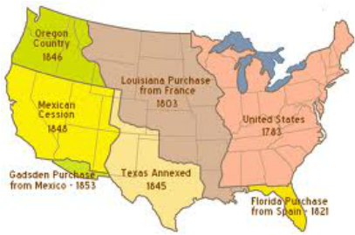
Westward Expansion
Monroe Doctrine | Legislation  Foreign  Policy,  1865 - 1877
Expansionism | Britain & Canada

The Era of Recostruction
1877
1865

The Gilded Age, 1877 - 1890
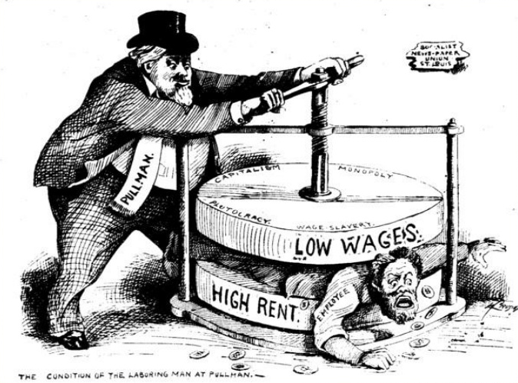

The period that followed Reconstruction is known as the Gilded Age. Politically, this was an age of limited political change and development, but of much political corruption. In addition, the economy continued to grow, particularly industry in the North and agriculture in the newly occupied areas of the West, but the economy was dominated more than ever by a few industrialists and businessmen. The period also saw the first major attempts to organise national labour unions as well as an ever-growing influx of immigrants which, to some extent, challenged the US way of life. The segregation and discrimination against African Americans in the South was further reinforced during this period and the Native Americans of the Plains were more or less confined to the Reservations. The Gilded Age also included the announcement of the end of the frontier, as well as the famous Turner essay on the significance of the frontier to the development of the USA.

 | President | Key Legislation | Successes | Failures
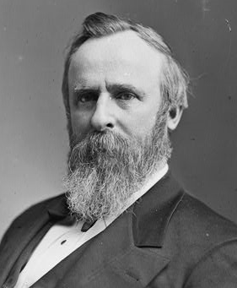 | Rutherford B. Hayes
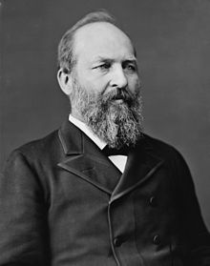 | 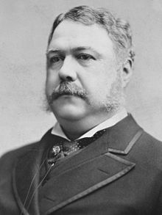  James A. Garfield
 | Chester A. Arthur
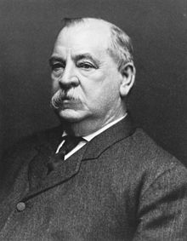 | Grover Cleveland

Vanderbilt | Carnegie  The  “Robber  Barons”
Rockefeller | Morgan

Trade Unions | National Railroad Strike  Organised  Labour
The Knights of Labor | Haymarket Bomb Outrage

Motivation “Pull” Factors | Motivation “Push” Factors  Immigration
American Reaction | Nativism & Objection

Migration | Segregation  African  Americans
Legislation | Education

The Dawes Act | Battle of Wounded Knee  Native  Americans
Life on the Plains +/- | Turner Essay & Historiography

Expansion of the Navy | Hawaii  Foreign  Policy
Latin America | Motivation / Aims

1890

Progressivism & Imperialism, 1890 - 1912
The Gilded Age
1877
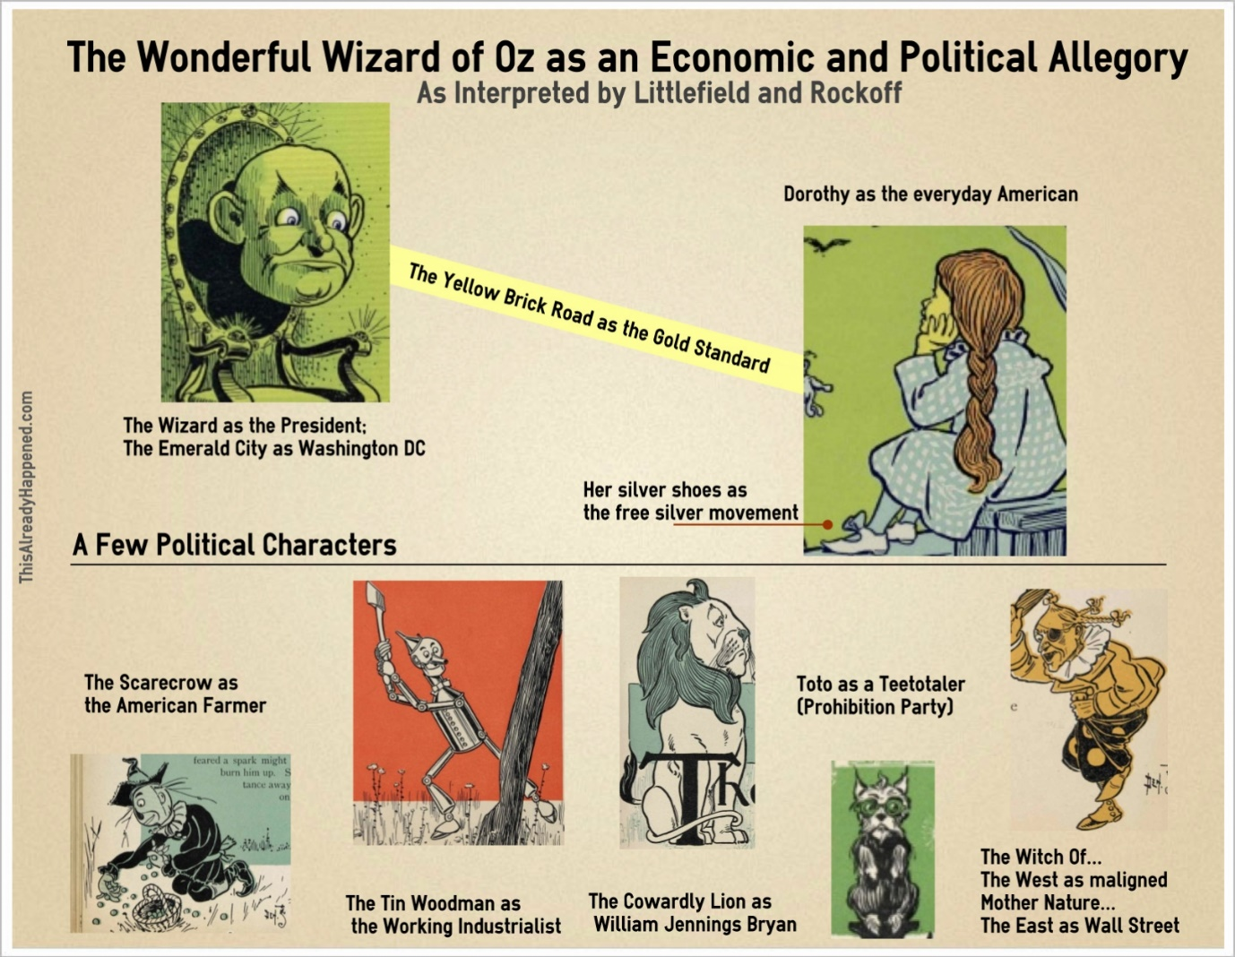

There were profound political, economic and social changes during this period. Politically, the Populist Party and the Progressive Movement greatly influenced the policies of Presidents Roosevelt and Taft. Economically, despite continued industrial growth, the USA experienced a second major depression in 1893. Mass immigration, stimulated by economic expansion, had a major impact on the racial and ethnic mix as well as the living conditions of many towns and cities, especially in the more industrialised North. African Americans continued to experience institutionalised segregation and discrimination in the South while those that moved to the North to seek work in industry suffered from inferior living and working conditions. This was also a period of significant change in American foreign and imperial policies, particularly in the years that followed the Spanish-American War of 1898.
Silver | Agriculture  Populism
1896 Election | Populist Party

Definition | Reasons for Emergence  Progressivism
Aims: Economic | Aims: Social

 | Theodore Roosevelt | William Taft
Evidence
for Progressivism
Evidence against Progressivism

Industry | Agriculture  Socio-Economic  Change
Workers | Immigration

Segregation | Voting Rights  African  Americans
Former Slave Case Studies | Position by 1912

The Pacific | Latin America  Foreign  Policy
Spanish-American War, ‘98 | The Far East

1920

Progressivism and Imperialism
1890

Emergence on the World Stage, 1912 - 1920
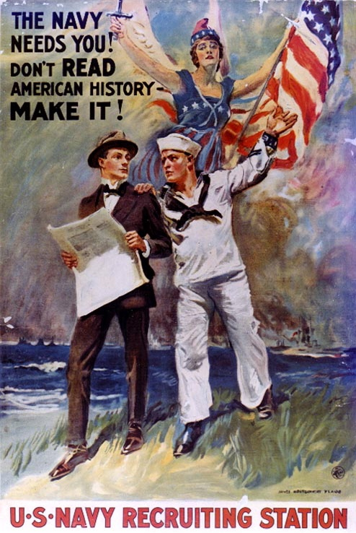

Woodrow Wilson served two terms as president of the USA. His first term saw a series of important progressive reforms in banking, finance and the economy, as well as continuing the anti-trust legislation of his predecessors. There was limited reform during his second administration mainly due to American involvement in the First World War. Wilson’s policies abroad were very much influenced by his own views of moral diplomacy – his ideas of what was right and wrong. He was prepared to intervene in Latin American countries, especially Mexico, if he felt the government was corrupt and/or evil. He maintained US neutrality during the first three years of the war, although America became increasingly anti-German due to the sinking of ships, including the Lusitania by German U-Boats. In April 1917, the USA declared war on Germany, partly because of the resumption of unrestricted U-Boat warfare. American forces, although relatively slow to arrive in Europe, eventually played an important role in the defeat of Germany. Involvement in the war led to changes in the USA itself including war production, employment and to the position of African Americans. Wilson, with the publication of his Fourteen Points in 1918, hoped to have a decisive influence on the peace conference.
President Wilson | Legislation: Economic  ‘The New Freedom,’  1912 - 1920
Legislation: Social | African Americans

Wilson’s Aims & Motivations | Pro-Neutrality  US  Neutrality
Anti-Neutrality | International Relations

Motivation for War | African Americans  World  War  One
The Economy | Women

The Fourteen Points | The League of Nations  Isolationism
Economy & Society | Politics

1920
1912
Neutrality, WW1 and Isolationism

Return to Normalcy, 1919 - 1932
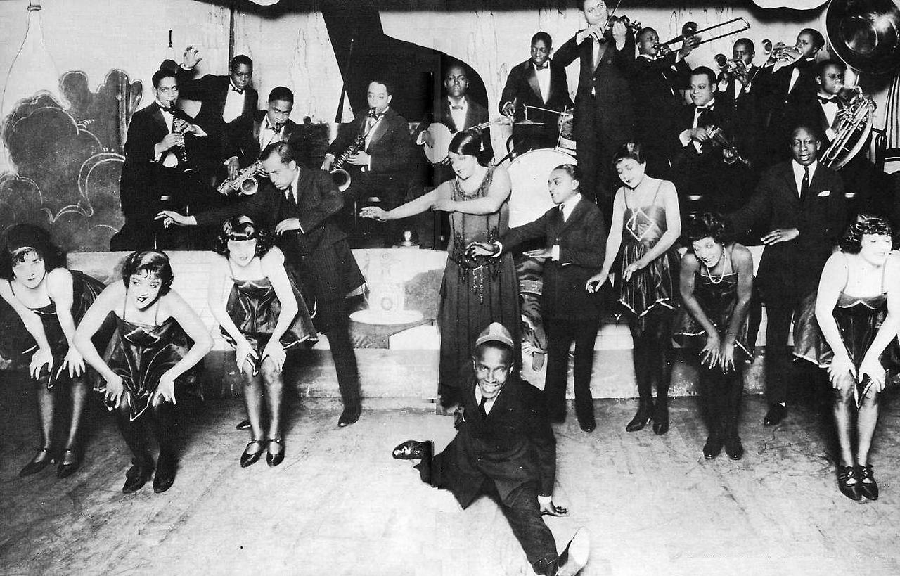

The Republicans dominated this period of American history with three presidents: Harding, Coolidge and Hoover. For most of the years, 1919 – 1929, the USA experienced an unprecedented boom in the economy due to the benefits of the First World War, as well as the impetus provided by developments in the car industry. The 1920s was nicknamed the ‘Age of Jazz,’ with many people enjoying a much better lifestyle and significant changes in entertainment and the role of women. However, not everyone enjoyed the prosperity. There was increasing hostility towards immigrants and growing support for the Ku Klux Klan. The boom years ended with the Wall Street Crash of 1929 which was followed by the Great Depression and massive unemployment. Hoover’s limited attempts to deal with the Depression led to the election of Roosevelt as president in 1932.
 | Warren Harding | Calvin Coolidge
Successes
Failures

Aims | International Conferences  Foreign  Policy
USA & Europe | Latin America

Government & ‘Rugged Individualism’ | Consumerism and Advetising  Economic  Boom
Industry and Technology | Stock Market

Women +/- | Entertainment +/-  The  ‘Jazz Age’
Prohibition & Crime +/- | Intolerance & Immigration +/-

President Hoover | Legislation  The Wall Street Crash
Economic Impact | Social Impact

Industry | Agriculture  The Great  Depression
Reasons for the Crash | Impact of the Crash

1932
The Jazz Age
1919
Practice Questions (Own Knowledge)

The Era of Reconstruction, 1865 – 1877
- The main reason for the growth in the US economy from 1865 to 1877 was the improvements in transport. Assess the validity of tis view.
- The main reason for Westward expansion 1865 – 1877 was the “Manifest Destiny.” Assess the validity of this view.
- The main effect of Reconstruction for African Americans was the introduction of the Jim Crow Laws. Assess the validity of this view.

The Gilded Age, 1877 – 1890
- The most important reason for expansion West in the years 1865 to 1890 was the development of the railroads. Assess the validity of this view.
- The greatest threat to the position of African Americans in the South in the years 1865 – 90 was formal segregation. Assess the validity of this view.
- The main effect of increased immigration to the USA in the years 1865 to 1890 was the growth of “nativism”. Assess the validity of this view.

Progressivism and Imperialism, 1890 – 1912
- To what extent was the growth of imperialism in the years 1890 to 1912 due to the search for new markets?
- The main reason for the growth of the Progressive Movement in the years 1890 – 1912 was because of the need to regulate big business. Assess the validity of this view.
- To what extent was the regulation of big business the most important achievement of the Progressive Movement in the years 1890 – 1912?

Emergence on the World Stage, 1912 – 1920
- Wilson was the most progressive of the American presidents in the years 1890 to 1920. Assess the validity of this view.

Return to Normalcy, 1919 – 1932
- The main reason for the growth of the US economy, 1900 – 1930, was technological change. Assess the validity of this view.

