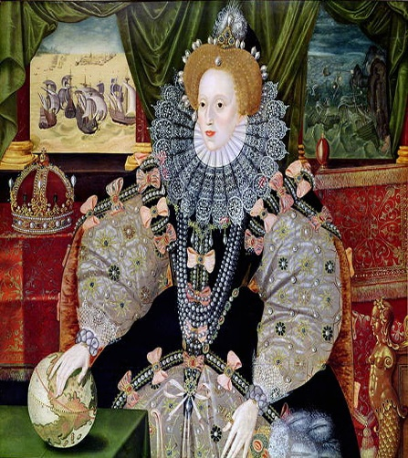
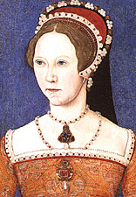
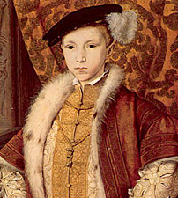
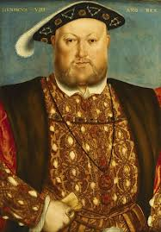
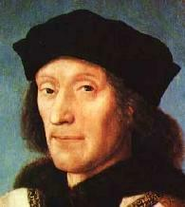
Private Study and Deeper Learning Guide
The Tudors, 1485 - 1603
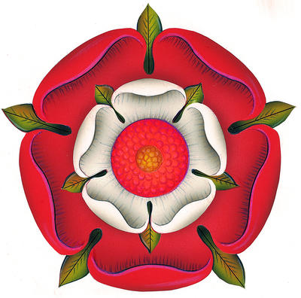
Key Themes Studied
- The Consolidation of Royal Power
- Character and Aims of Tudor Monarchs
- Rebellion and Revolt
- Socio-Economic Change
- Foreign Relations
- Religion and the Reformation
- Arts, Culture and Education

Core PS Task – For each of the above areas you might like to make and keep up-to-date a chronology of relevant developments for each theme. If you do this as you go along it will aid your revision and deepen your understanding of the bigger themes that run across the smaller topics we break the unit into.
Extension Task – You could also turn the chronologies into living graphs, visually showing the extent of each change and development over the period 1485 – 1603.
Date and Development / Event | Brief Description | Impact / Importance?

The following guide provides a number of ways for you to maximise and deepen your learning in your A-Level History Unit on the history of the Tudor dynasty. Many of these tasks should be completed in Private Study (PS) in addition to any homework tasks you have been set. You can use the core textbook and other key books available in the school library, as well as the following websites, to support you.

http://tudorhistory.org/
http://www.historyonthenet.com/tudors/tudorsmain.htm
http://spartacus-educational.com/
http://www.historytoday.com/martin-roberts/proper-history-and-sixth-form-history
http://www.historyextra.com/

The Tudors, 1485 - 1603
Private Study Guide
The Tudors: England 1485 – 1603. [Oxford AQA History Textbook]
Whilst studying in each unit, try to complete as many of the PS tasks set below as possible. You may also like to dip into the recommended reading to gain a sense of the historian’s opinion on the topic and some extra depth / detail to your understanding.

Henry VII, 1485-1509
Topics: | Page References: | Activity:
The Consolidation of Power  (Henry VII: Lessons 1-4)  - Battle of Bosworth  - Henry’s character and aims  - Early rebellions | 1-2  2-3  4-7 | A Level practice source question on page 7
Henry VII’s Government  (Henry VII: Lessons 8-10)  - Council and the Court  - Parliament  - Domestic Policy | 9-12  13-14  14-18 | A Level practice essay question on page 19
Foreign Relations, 1485-1509  (Henry VII: Lesson 6 & 7)  - Brittany and France  - Burgundy, Netherlands & Holy Roman Empire  - Scotland  - Ireland  - Marriage Alliances | 21-24  24-26  27  27-28  29-30 | A Level practice essay question on page 31

English Society  (Henry VII: Lesson 11)  - Structure of Society  - Regional Divisions & Rebellions | 33-38  38-41 | Find specific evidence to support or challenge Joyce Young’s interpretation on page 33
Economic Development  (Henry VII: Lesson 5 & 12)  (Social & Economic: Lessons 2-3)  - Agriculture  - Trade and Industry  - Exploration  - Prosperity and Depression | 43-45  45-48  48  49 | A Level practice essay question on page 50
Religion, Humanism, Arts and Learning  (Henry VIII, Religious Change: Lesson 1)  (Social & Economic: Lesson 6)  - Catholic Practice in England  - Religious Orders  - Religious Opposition  - Humanists  - Education | 51-54  55-56  56  56-58  58-60 | A Level practice essay question page 61
Henry VIII, 1509-1547
Topics: | Page References: | Activity:
Character and Aims of Henry VIII  (Henry VIII, Early Years: Lessons 1&2)  - Character  - Legacy of Henry VII  - Aims of Government | 63-66  66  67 (early) 68 (late) | A Level practice essay question on page 69
Government and Parliament  (Henry VIII, Early Years: Lessons 3-13)  (Henry VIII, Government: Lessons 1 & 2)  - Role of Parliament  - Wolsey  - The King’s “Great Matter”  - Thomas Cromwell  - Later Years | 71-72  72-75  75-77  77-81  81-82 | A Level practice source question on page 83
Foreign Relations  (Henry VIII, Early Years: Lessons 4-6)  (Henry VIII, Government: Lessons 4 & 5)  (Social & Economic: Lesson 2)  - Early Foreign Policy  - Mid Foreign Policy  - Late Foreign Policy  - Securing the Succession | 85-89  89-91  91-93  93-95 | A Level practice essay question on page 95
English Society  (Henry VIII, Religious Change)  - Elites and Commoners  - Regional Issues  - Religion  - Rebellions | 97-99  99-102  102-103  103-107 | A Level practice essay question on page 108
Economic Development  (Social & Economic: Lessons 2 – 5)  - Trade  - Exploration  - Prosperity and Depression | 109-110  111  111-113 | A Level practice essay question on page 113
Religion, Ideas and Reform  (Social & Economic: Lesson 6)  - Influence of Renaissance  - Church Reform  - Great Change? | 115-117  117-122  127 | A Level practice essay question on page 123

Instability and consolidation: ‘the mid-Tudor crisis’: 1547-63
Topics: | Page References: | Activity:
Edward VI, Somerset and Northumberland  (Edward VI: Lessons 1-4)  - Edward’s Inheritance from Henry  - Somerset’s Policies  - Northumberland’s Policies  - The Succession  - Foreign Policy | 125-126  126-127  127-129  129  129-130 | A Level practice essay question on page 131
The social impact of religious and economic change under Edward IV  (Edward VI: Lessons 1 to 5)  - Religious change  - Economic change  - Rebellions | 134-138  138-139  139-142 | A Level practice essay question on page 143
Mary I and her ministers  (Mary: Lessons 1-4)  - Failure of Northumberland’s Plan  - Royal government  - Spanish marriage  - Foreign Policy | 145-146  146-147  147-149  149-150 | A Level practice essay question on page 152
The social impact of religious and economic changes under Mary I  (Mary: Lessons 2, 4-5)  - Religious change  - Economic change  - Wyatt’s rebellion | 154-158  158-159  159-161 | A Level practice essay question on page 163

Elizabeth I, 1558-1603
Topics: | Page References: | Activity:
Elizabeth’s consolidation of power  Government: Lesson 1 | p. 166-167 | Complete the newspaper activity on page 167
Elizabeth’s Court  Government: Lesson 2-4 | p. 183-184 | Complete the evaluation activity on Haigh’s extract on page 183
Elizabeth’s Council  Government: Lesson 5 | p. 185-187 | Complete the activity on page 186 that requires you to study an act of the Privy Council.
Elizabeth’s Parliament  Government: Lesson 6 | p. 189-193 | Complete summary chart for revision on page 194
Local Government  Government: Lesson 7 | p. 191-193 (Hodder textbook) | Two activities on Sources G and H on page 192.
Elizabeth’s Personal Religious Views and Settlement  Religion: Lessons 1, 2 and 3 | p. 167-170 | The group work activity on page 168 (to be completed as individuals or in pairs/groups).
Threat of Catholics  Religion: Lessons 4-5 | p. 228-229 | Revision spider-diagram on Catholic threat on page 230
Society Change  Problems  Discontent and rebellions | p. 210-212  p. 213-214 | A Level practice essay question on page 216
Economic Development  Trade  Exploration and colonisation  Prosperity and depression | p. 217  p. 218  p. 219 | A Level practice essay question on page 223
The Golden Age  Religious developments  English Renaissance | p. 225-231  p. 232-234 | A Level practice essay question on page 232  A Level practice essay question on page235

The below are films and books that you could watch and read to extend your understanding of the period. For each you will need to consider what it says about the period and how accurate the portrayal of events is.

Early Tudor:
- TV: The White Queen (2013) – a depiction of the Wars of the Roses, concluding with the Battle of Bosworth.
- Book - Fiction: The Cousin’s War Series – ‘The White Queen’, ‘The Red Queen’, ‘The Lady of the Rivers’, ‘The Kingmaker’s Daughter’ and the ‘White Princess’.
- Book: ‘The Winter King’ by Thomas Penn – a consideration of the rule of Henry VII.

Henry VIII:
- Book: ‘Wolsey: The Life of King Henry VIII’s Cardinal’ by John Matusiak – available in the school library!
- Book: ‘Henry VIII’ by Robert Lacy – available in the school library!
- Book: ‘Six Wives: The Queens of Henry VIII’ by David Starkey
- Film: The Other Boleyn Girl (2008)
- Film: A Man for all Seasons (1966)
- TV: The Six Wives of Henry VIII (1970)
- TV: The Tudors (2007-2010)
- Film: Anne of the Thousand Days (1969)

Mid-Tudor Crisis:
- Book: Britain 1558-1689: Textbook – available in the school library!

Elizabeth:
- FILM: Elizabeth (1998)
- FILM: Elizabeth: The Golden Age (2007)
- TV: Elizabeth R (1971)
- TV: The Virgin Queen (2005)
- Book: ‘Elizabeth’ by David Starkey – available in the school library!
- Film: The Private Lives of Elizabeth and Essex (1939)
Filmography & Literature Links

