Reading List – Chaucer
The following books and other texts will help you to immerse yourself in the time period in which Chaucer was writing. Spend the Summer getting to grips with all things Medieval!
Non-Fiction:
- ‘The Time Traveller’s Guide to Medieval England’ – Ian Mortimer
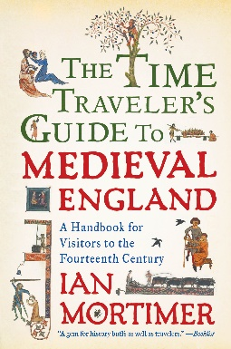
Imagine you could travel back to the fourteenth century. What would you see, and hear, and smell? Where would you stay? What are you going to eat? And how are you going to test to see if you are going down with the plague?

In The Time Traveller's Guide... Ian Mortimer's radical new approach turns our entire understanding of history upside down. History is not just something to be studied; it is also something to be lived, whether that's the life of a peasant or a lord. The result is perhaps the most astonishing history book you are ever likely to read; as revolutionary as it is informative, as entertaining as it is startling.

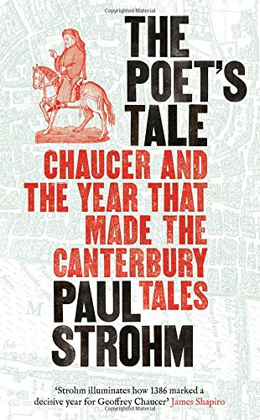
- ‘The Poet’s Tale: Chaucer and the year that made the Canterbury Tales’ – Paul Strohm
As the year 1386 began, Geoffrey Chaucer was a middle-aged bureaucrat and sometime poet, living in London and enjoying the perks that came with his close connections to its booming wool trade. When it ended, he was jobless, homeless, out of favour with his friends and living in exile.
Such a reversal might have spelled the end of his career; but instead, at the loneliest time of his life, Chaucer made the revolutionary decision to 'maken vertu of necessitee' and keep writing. The result - the Canterbury Tales - was a radically new form of poetry that would make his reputation, bring him to a national audience, and preserve his work for posterity.
In The Poet's Tale, Paul Strohm brings Chaucer's world to vivid life, from the streets and taverns of crowded medieval London to rural seclusion in Kent, and reveals this crucial year as a turning point in the fortunes of England's most important poet.

- ‘Everyday Life in Medieval London: From the Anglo Saxons to the Tudors’ – Toni Mount
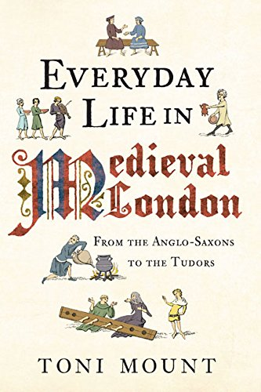
Our capital city has always been a thriving and colourful place, full of diverse and determined individuals developing trade and finance, exchanging gossip and doing business. Abandoned by the Romans, rebuilt by the Saxons, occupied by the Vikings and reconstructed by the Normans, London would become the largest trade and financial centre, dominating the world in later centuries. London has always been a brilliant, vibrant and eclectic place - Henry V was given a triumphal procession there after his return from Agincourt and the Lord Mayor's river pageant was an annual medieval spectacular. William the Conqueror built the Tower, Thomas Becket was born in Cheapside, Wat Tyler led the peasants in revolt across London Bridge and Chaucer's Canterbury Tales was the first book produced on Caxton's new printing press in Westminster. But beneath the colour and pageantry lay dirt, discomfort and disease, the daily grind for ordinary folk. Like us, they had family problems, work worries, health concerns and wondered about the weather.
Fiction:
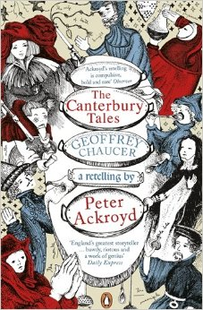
- ‘The Canterbury Tales: A Retelling’ – Peter Ackroyd
Making a major part of England's literary heritage accessible to a new audience, Peter Ackroyd's The Canterbury Tales: A Retelling renders Geoffrey Chaucer's timeless tales in lucid, compelling modern English prose.

On a pilgrimage to Canterbury, a group of travellers agree to a storytelling competition. As they make their way on the road, they drink, laugh, flirt, argue and try to outdo each other with their tales. From the exuberant Wife of Bath's Arthurian legend to the Miller's worldly, ribald farce, these tales can be taken as a mirror of fourteenth-century London. Incorporating every style of medieval narrative - bawdy anecdote, allegorical fable and courtly romance - the tales encompass a blend of universal human themes, retold here for our times by bestselling author Peter Ackroyd.

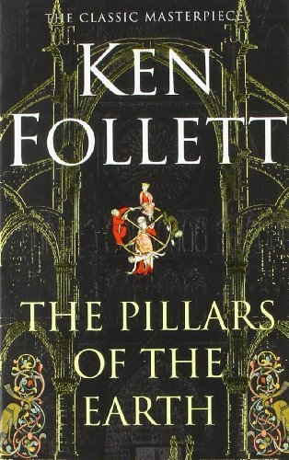
- ‘The Pillars of the Earth’ – Ken Follett
Set in 12th-century England, Ken Follett's The Pillars of the Earth chronicles the building of the greatest Gothic cathedral the world has known and the struggle between good and evil that will turn church against state, brother against brother.
Tells the story of Philip, prior of Kingsbridge, a devout and resourceful monk driven to build the greatest Gothic cathedral the world has known; of Tom, the mason who becomes his architect - a man divided in his soul; of the beautiful, elusive Lady Aliena, haunted by a secret shame; and of a struggle between good and evil.

Other texts:

- ‘The Pillars of the Earth’ – DVD/TV series

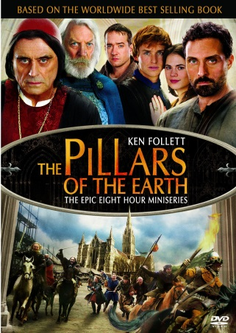
The TV version of the novel – a great way to relax, see the Medieval period in action… and it’s got Eddie Redmayne and Matthew MacFadyen in it!

- ‘In Our Time’ Radio 4 programmes – there are several that you can listen to online that deal with the Medieval period, most obviously the one on Chaucer!

- ‘Inside the Medieval Mind’ – BBC4 documentary – available on iPlayer. There are 4 episodes: Knowledge, Sex, Belief, Power

- ‘The Hollow Crown’ – BBC2 films – DVD collection of remakes of Shakespeare plays
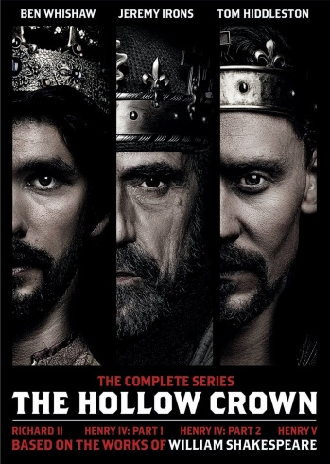
The Plantagenet line of Kings ruled the Middle Ages – Edward III, Richard II and Henry IV
The series pulls together and reimagines four of William Shakespeare's plays, from Richard II and Henry V to both parts of Henry IV. Then, it brings in a cast boasting the likes of Jeremy Irons, Patrick Stewart and Tom Hiddleston, acting heavyweights who make much of the already strong material. The end result is something very special indeed.
The idea of bringing four plays together in one mutli-part production is a strong one anyway, but The Hollow Crown really is an accessible yet deep look at three different kings and their differences. Of course, that leaves ample room for politics, power struggles, family and conflict, and the sheer ambition of what's on the screen is refreshing and engrossing.

- ‘A Knight’s Tale’ – 2001

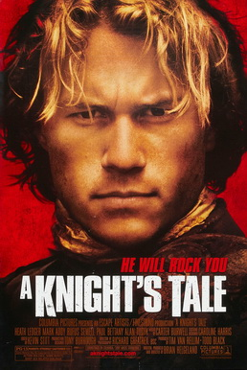
A Knight's Tale is a medieval adventure comedy-drama film written, produced, and directed by Brian Helgeland. The film stars Heath Ledger, Paul Bettany as Geoffrey Chaucer and James Purefoy as Sir Thomas Colville/Edward, the Black Prince.
Told in an anachronistic style with many modern references, the film follows a peasant who is pretending to be a knight, along with his companions, in the world of medieval jousting. William poses as a knight and competes in tournaments, winning accolades and acquiring friendships with such historical figures as Edward, the Black Prince of Wales and Geoffrey Chaucer.
The film takes its title from Chaucer's "The Knight's Tale" in his Canterbury Tales, though the plot is not especially similar.

