AQA English Language Paper 2:
Writers’ Viewpoints and Perspectives

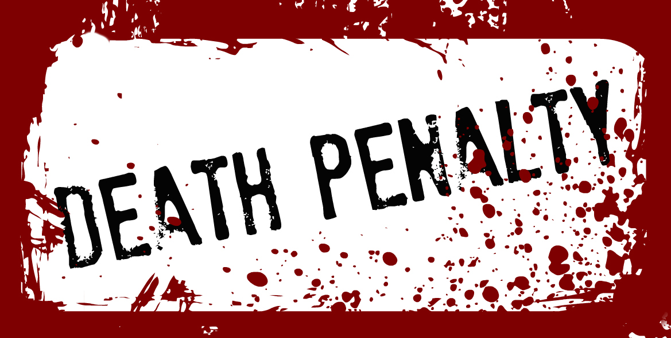

Two non-fiction texts linked
by the same theme or topic

Public hangings were brought to an end in Britain by the Capital Punishment Amendment Act of 1868, but the sentence was still carried out behind closed doors. This eyewitness account of a visit to the prison gallows appeared in The Daily Telegraph, 30th November 1881.  SOURCE A:  Just as the clock was striking half past eight this morning the little wicket gate of the lodge of Lewes jail was opened by a warder for the purpose of admitting some dozen and a half gentlemen who till then had lingered in the garden which belongs to the prison. A bright sunshine had succeeded a gusty night, and was rapidly driving away the mists that still hung over the South Down hills.  At last we came to the yard – the one for which we were particularly bound – a large irregular space, bounded on one side by the prison, and on three others by high walls. At the end, however, were two objects which forced themselves upon the view. In the right-hand corner as we looked upon them rose a couple of thick black posts, with a huge cross piece, from which dangled a staple and a long, thick rope; in the other, about 10 yards distance, an open grave.  As we filed into the yard, I noticed that we were being one by one saluted by a somewhat diminutive man clothed in brown cloth, who raised his hat and greeted each arrival with a “good morning, gentlemen.” To my horror, the man in the brown coat proved to be no stranger wandering about, but the designer of the horrible structure on the right, and the official most closely connected with that and the open grave. William Marwood it was who thus bade us welcome, and the straps on his arms were nothing less than his “tackle”.  I confess to a shudder as I looked upon the girdle and arm pieces that had done duty on so many a struggling wretch, and half expected that the man who carried them would have attempted to hide them. But no such thing! To him they were implements of high merit, and together with the gallows formed what he now confidentially informed his hearers was “an excellent arrangement”. It was evident that in the gallows and the tackle too he had more than a little pride.  “That rope that you see there,” said he, as he gazed admiringly at the crossbar of black wood, “is two and a half inches round. I’ve hung nine with it, and it’s the same I used yesterday.” Nor does he manifest the quaver of a muscle as he went on to point to certain peculiarities of design in his machinery of death. Had he been exhibiting a cooking apparatus, a patent incubator, or a corn mill, he could not have been more pleased or more calm. To Marwood the whole thing evidently seemed a triumph of art.  At length a warder came battling up, and with a bundle of keys in his hand beckoned to Marwood. It wanted about 10 minutes to 9 o’clock, and the doomed man was waiting. “Ready for you,” remarked the warder, and with an expectant look Marwood gathered up his “tackle” and followed. With an easy skip and a hop, as though he were answering an agreeable call, he left us and disappeared towards the cell of the man about to die. | 5  10  15  20  25  30

SOURCE B: Taken from www.usnews.com , September 29th, 2014  The author of this American newspaper article is in favour of the death penalty.  How the Death Penalty Saves Lives:  Capital punishment curbs criminal behaviour and promotes a safer country.  On Sept. 10, Earl Ringo Jr. was executed in Missouri. Before you decide whether or not this is right, consider what Ringo did. In July 1998, Ringo and an accomplice planned to rob a restaurant where Ringo had previously worked. Early one morning, they followed delivery truck driver Dennis Poyser and manager-in-training Joanna Baysinger into the building before shooting Poyser to death and forcing Baysinger to hand over $1,400. Then, Ringo encouraged his partner to kill her. A jury convicted Ringo of two first-degree murders.  Some crimes are so heinous and inherently wrong that they demand strict penalties – up to and including life sentences or even death. Most Americans recognize this principle as just. A Gallup poll from May on the topic found that 61 percent of Americans view the death penalty as morally acceptable, and only 30 percent disagreed. Even though foes of capital punishment have for years been increasingly vocal in their opposition to the death penalty, Americans have consistently supported capital punishment by a 2-to-1 ratio in murder cases. They are wise to do so.  Studies of the death penalty have reached various conclusions about its effectiveness in deterring crime. Indeed, recent investigations, using a variety of samples and statistical methods, consistently demonstrate a strong link between executions and reduced murder rates. For instance, a 2003 study by Emory University researchers of data from more than 3,000 counties from 1977 through 1996 found that each execution, on average, resulted in 18 fewer murders per county. In another examination, based on data from all 50 states from 1978 to 1997, Federal Communications Commission economist Paul Zimmerman demonstrated that each state execution deters an average of 14 murders annually.  A more recent study by Kenneth Land of Duke University and others concluded that, from 1994 through 2005, each execution in Texas was associated with "modest, short-term reductions" in homicides, a decrease of up to 2.5 murders. And in 2009, researchers found that adopting state laws allowing defendants in child murder cases to be eligible for the death penalty was associated with an almost 20 percent reduction in rates of these crimes.  In short, capital punishment does, in fact, save lives. That's certainly not to say that it should be exercised with wild abandon. However, the criminal process should not be abused to prevent the lawful imposition of the death penalty in capital cases.  The execution of Ringo was morally just. And it may just save the lives of several innocents. | 5  10  15  20  25

Q1: Read lines 5 to 15 of Source A.
Choose four statements below which are TRUE. [4 marks]

- The executioner is dressed in brown clothing

- This event took place in the evening

- The rope is described as short and thick

- The rope is described as long and thick

- The grave is about 15 yards from the gallows

- The author describes two large, black posts

- The grave is about 10 yards from the gallows

Q2: Refer to Source A and Source B. Write a summary of the differences in the
writers’ attitudes to the death penalty.
[8 Marks]

Q3: Refer to Source B.
How does the writer use language to convey Marwood’s attitude to the death penalty.
[12 Marks]

Q4: Refer to Source A and Source B.

Compare how the writers convey their different attitudes to the death penalty. [16 Marks]
In your answer, you should:

- compare their different attitudes
- compare the methods they use to convey their attitudes
- support your ideas with quotations from both texts

Section B: Writing

You are advised to spend about 45 minutes on this section.
Write in full sentences.
You are reminded of the need to plan your answer.
You should leave enough time to check your work at the end.

Q5

“No country which has the death penalty can truly call itself a civilised country.”

Write a letter to your MP, arguing in support or against capital punishment.

(24 marks for content and organisation
16 marks for technical accuracy)

[40 marks]

