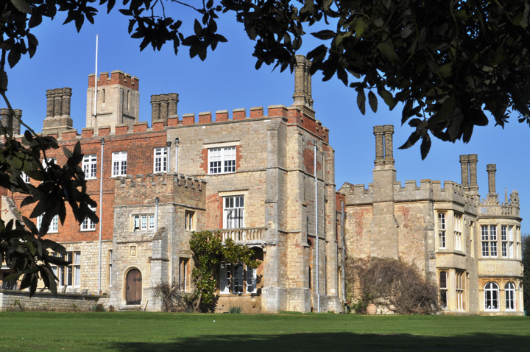

Dessert

* Watch any Shakespearian tragedy
* Watch **Hamlet** at the Barbican Theatre London or the live screening in Autumn
* Watch modern version of **Hamlet** with Ethan Hawke
* Read a biography of F Scott Fitzgerald
* Read **Careless People** :**Murder, Mayhem and the Invention of The Great Gatsby-**Sarah Churchill

Mains

Read your set texts for this year.

* **Hamlet**- William Shakespeare
* **The Grapes of Wrath**-John Steinbeck
* **The Great Gatsby-**F .Scott Fitzgerald

Starter

Watch the film versions of your set texts:

* Baz Lurhman’s ‘The Great Gatsby’
* Kenneth Branagh’s ’Hamlet’
* ‘The Grapes of Wrath’- 1940 version

Read:

* **The Portrait of a Lady**-Henry James
* **The Adventures of Huckleberry Finn**- Mark Twain
* **Sister Carrie**-Theodore Dreiser
* **My Antonia** –Willa Cather
* **The Age of Innocence**- Edith Wharton
* **The Sound and the Fury**-William Faulkner
* **A Farewell to Arms**-Ernest Hemingway
* **Native Son**-Richard Wright

This is your summer menu to support your transition from GSCE to A level:

Main courses are compulsory.

Choose activities from the starter and dessert menus to enrich and develop your understanding ready for A level.

ENGLISH Literature A Level