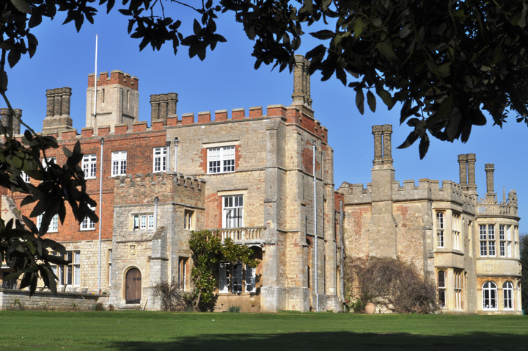

Mains

Refine your ideas for your language investigations.

Revise the topics studied at AS which your investigation has come from.

Research the case of ‘Genie’ – learning to acquire language.

Dessert

Record younger siblings, cousins and friends learning to speak.

Browse a range of baby/toddler books in the library or bookshop. Ask yourself how they support the development of language acquisition.

Starter

Explore one or two of David Crystal’s top ten books on the English Language:

1. The OED
2. The use of English by Randolph Quirk
3. A History of the English Language by Albert C Baugh
4. Roget’s Thesaurus
5. Mother Tongue by Bill Bryson
6. A Comprehensive Grammar of the English Language by Randolph Quirk, Sidney Greenbaum,
7. The Longman Grammar of Spoken and Written English
8. The Cambridge History of the English Language
9. The Cambridge Guide to English Usage by Pam Peters
10. The Cambridge Encyclopaedia of the English Language by David Crystal

This is your summer menu to support your transition from AS to A2:

Main courses are compulsory.

Choose activities from the starter and dessert menus to enrich and develop your understanding ready for A2.

ENGLISH LANGUAGE A2