Changing Perceptions of Cromwell in the Classroom
Prince’s Teaching Institute, 5 November 2016
Dr Andrew Hopper, University of Leicester

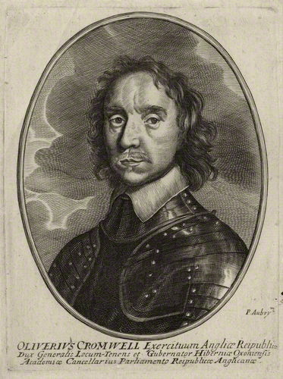

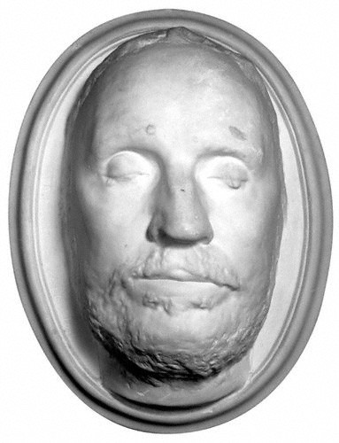

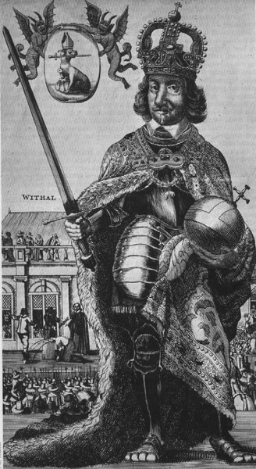

Timeline
25 Apr 1599 Born in Huntingdon
2 Jul 1644 Battle of Marston Moor
14 Jun 1645 Battle of Naseby
17-19 Aug 1648 Battle of Preston
30 Jan 1649 Execution of Charles I
26 Jun 1650 Cromwell replaced Fairfax as General of the New Model
3 Sep 1650 Battle of Dunbar
3 Sep 1651 Battle of Worcester
20 Apr 1653 Cromwell dissolves the Rump Parliament by force
Dec 1653 Cromwell appointed Lord Protector
3 Sep 1658 Death of Oliver Cromwell
25 May 1659 Resignation of Richard Cromwell
29 May 1660 ‘Oak Apple Day’: Charles II’s entry to London

Abstract
This talk will examine recent developments in the historiography of Oliver Cromwell. It will discuss his changing roles as farmer, soldier and statesman before, during and after the civil wars, as well as his interaction with his contemporaries and their impressions of him. The talk will touch on his involvement in the trial and execution of Charles I, and assess the significance of his role in the interregnum regimes that followed. It will conclude by investigating how he has been remembered and the legacy of his impact in Britain and Ireland since.

Questions
1. How important was Cromwell’s contribution to victory in the three civil wars?
2. How effective was Cromwell as a head of state?
3. How have views of Cromwell changed over time and why does he still provoke so much controversy as a historical figure?

Bibliography
Andrew Barclay, Electing Cromwell: The Making of a Politician (Pickering & Chatto, 2011)
Martyn Bennett, Oliver Cromwell (London, 2006)
Ian Gentles, God’s Warrior: Oliver Cromwell and the English Revolution (Basingstoke, 2011)
Andrew Hopper, Sir Thomas Fairfax and the English Revolution (Manchester, 2007)
Patrick Little (ed.), The Cromwellian Protectorate (Woodbridge, 2004)
Patrick Little and David Smith, Parliaments and Politics during the Cromwellian Protectorate (Cambridge, 2007)
Alan Marshall, Oliver Cromwell, Soldier: The Military Life of a Revolutionary at War (London, 2004)
Jane Mills (ed.), Cromwell’s Legacy (Manchester, 2012)
John Morrill (ed.), A New Critical Edition of All the Writings and Speeches of Oliver Cromwell 4 vols. (forthcoming)
Jason Peacey (ed.), The Regicides and the Execution of Charles I (Basingstoke, 2001)
Micheál Ó Siochrú, God’s Executioner: Oliver Cromwell and the Conquest of Ireland (London, 2008)

